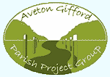

AVETON GIFFORD PARISH PROJECT GROUP

OPEN AFTERNOON & AGM

October 16th – in the village hall – an open afternoon from 3.30 until 7.00

AGM meeting at 7.00

The Project Group will hold the AGM this year on October 16th, and would like to invite you all; so much interest was shown in the old photos and records of the Primary School here in the village that the group would like people to have the chance to look again, or to see what was on display if they missed it the first time at the Church Fete.

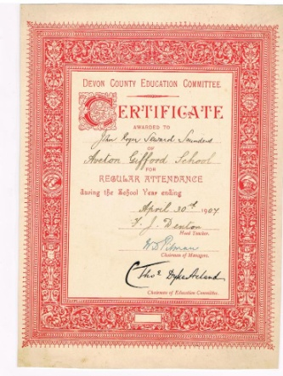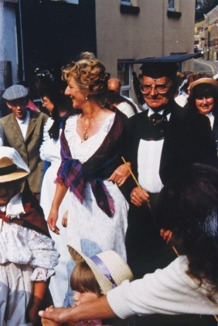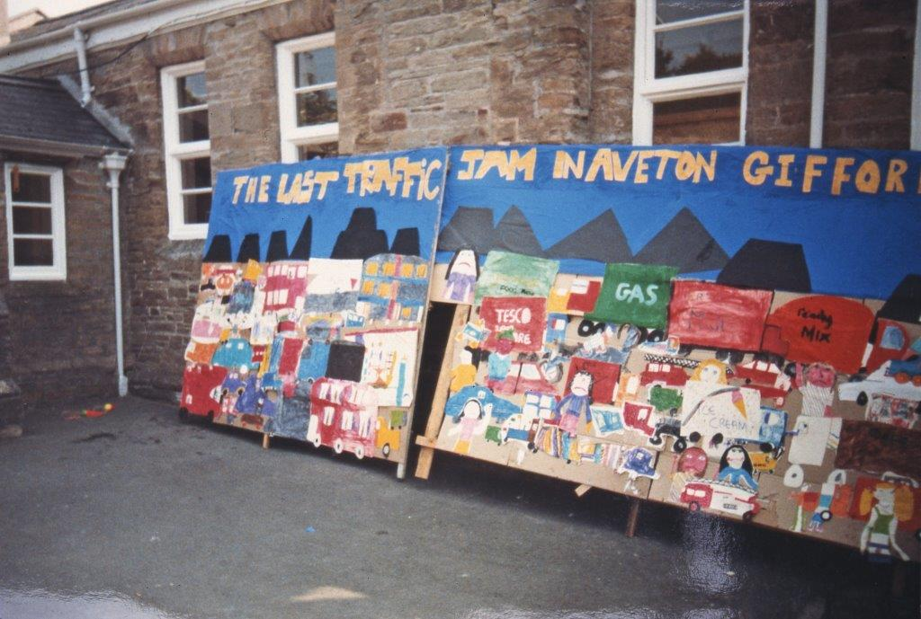

The group will hold a "drop-in" open afternoon in the village hall from 3.30 until 7.00 for you to call in and spend as long as you want browsing through the photos and records, with a cup of tea and a slice of home-made cake. Please do come in and join us after school or when you are back from work (no entry fee.) Maybe you’d also like to find out what the Project Group is, and what we do – please feel free to come in and talk to us there.
At 7.00 the Annual General Meeting will be held in the hall, with an open invitation to all. The Project Group is open to everyone, membership is free, and you don't have to join the committee to join in!

