St Ann’s Chapel
  - Assessment of local housing characteristics, community amenities and facilities to assist with the Bigbury Neighbourhood Plan.
St Ann’s Chapel Introduction:
The village is arranged around the central features of the Pickwick Inn, Holywell Stores and a few older original houses such as Little Coombe. The B3392 is intersected here with the roads to Averton Gifford and Ringmore forming the central hub of the village.
The Pickwick Inn with its Grade 11 listed status is the main focal centre with other local facilities all being close by and to the East of the B3392 including Bigbury Memorial Hall and car park, Holywell Stores and car park, Coastguard Station, playground and football pitch.
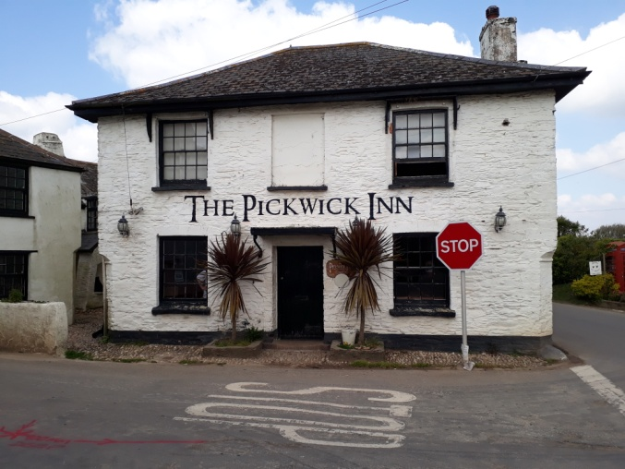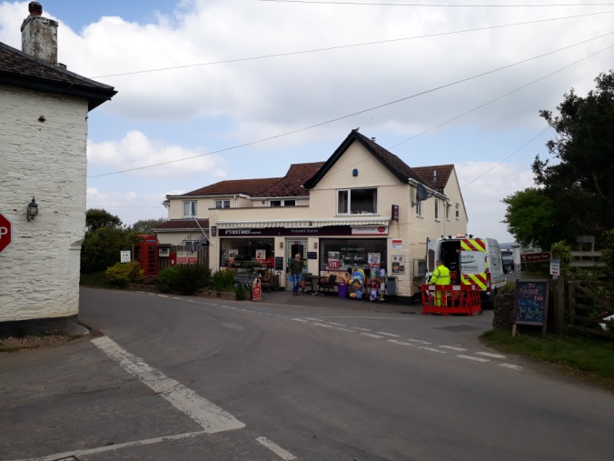
The Pickwick Inn Holywell Stores
The Pickwick Inn was an inn and resting place on the road between Aveton Gifford, Kingston and Modbury where people stopped to use the facilities of the holy well. At the beginning of the 20th century there were only a few cottages in this hamlet, including the local constabulary and a bakers. The Holywell Stores dates back to the years just before the Great War of 1914-18. The Hilltop development, built to provide affordable housing was originally built in the 1950’s. The Memorial Hall was also built in the 1950s.
Housing Description:
The houses around the village are essentially modest sized properties comprising mostly traditional 2-storey houses with painted white rendered walls with smaller timber framed windows at eaves level and slate roofs.
The height of the properties is generally quite low with many of the houses actually being ‘sunken’. The houses to the SW of the village are lower than the adjacent fields. The roofs are mostly hipped with some gable ended and some with dormer windows.
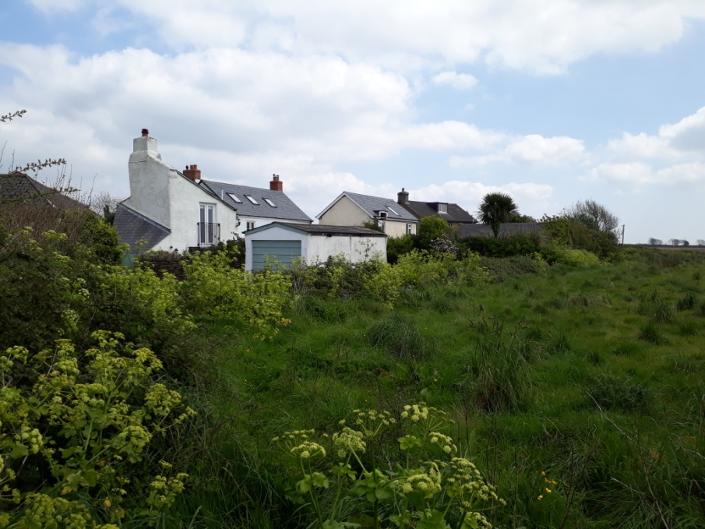
Some typical Devonshire features can be seen around the village including curved corners to the building and large dominating chimney breasts.
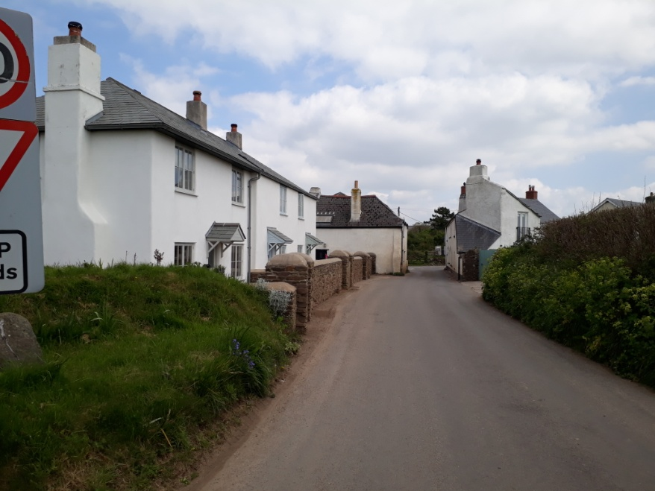
The approach from Ringmore.
Large chimney breasts are visible on many of the old and new houses.
Sea views are a feature of many properties to the SW of St Ann’s Chapel which has helped make this an attractive area to live and stay. This aspect should be protected as a current amenity to retain the character of the village.
The general mix of properties includes both detached and terraced houses with a few bungalows scattered around the village.
A large part of St Ann’s Chapel comprises rented housing association properties in Hilltop, where the more recently built (12 year old) semi-detached houses reflect the style and size of the original houses. The walls have tile hung upper sections with painted render walls below. They also have hipped slate tiled roofs and white window frames. Hilltop generally has small gardens with large open spaces between them.
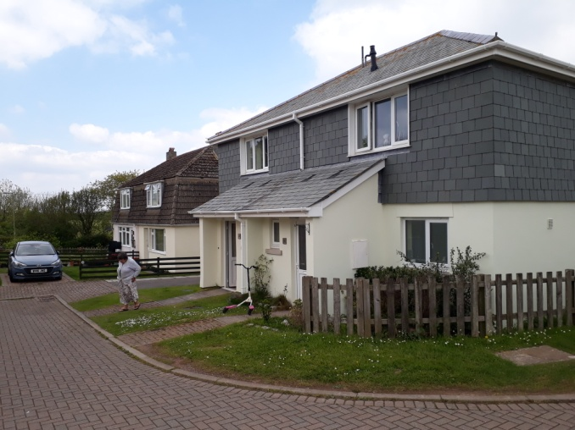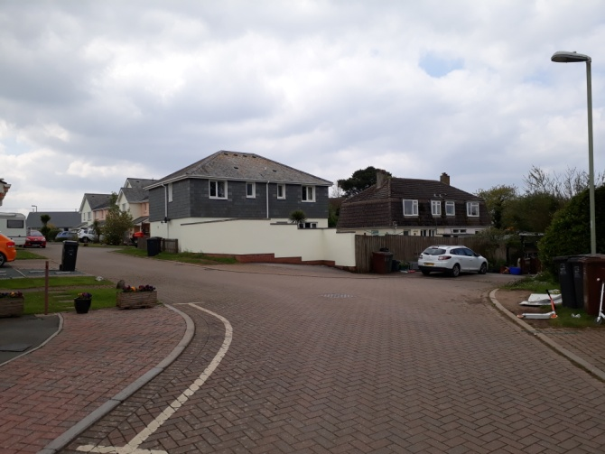
Old and new houses seen together at Hilltop.
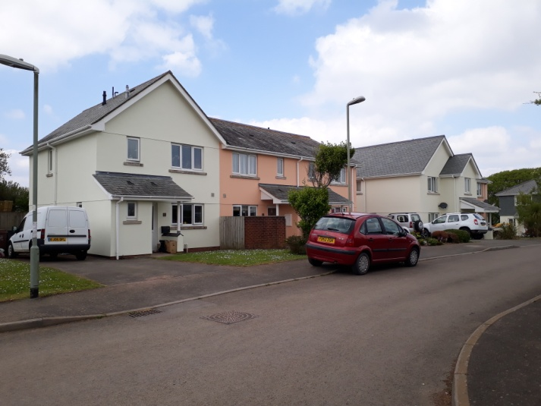 Other Hilltop houses without the hung tiles.
Assets and Amenities:
There are several areas and features around the village of distinct character which should be preserved. Some of these are identified below.
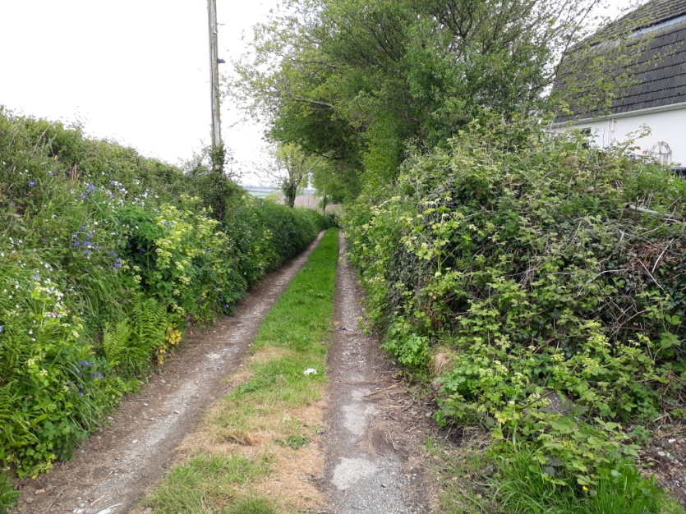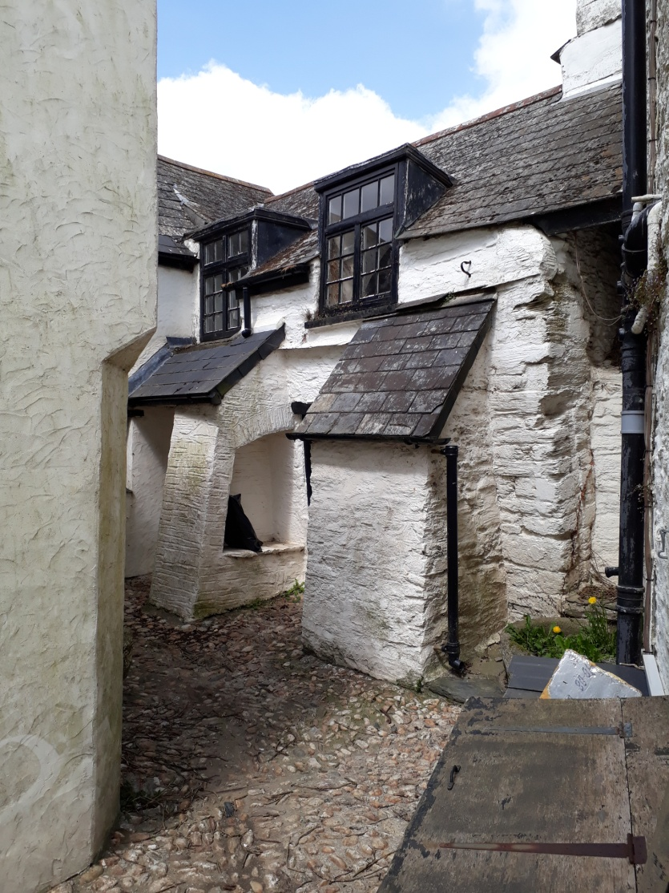
The tree lined lane to Holy Well Farm provides a natural habitat for wildlife and links Hilltop to the village with a footpath. Unfortunately nothing visible remains of the original well.
The courtyard to the side of the Pickwick Inn has unusual buttresses supporting the grade 11 listed Chapel within the pub. The Chapel in the pub also has some interesting murals and distinct architecture.
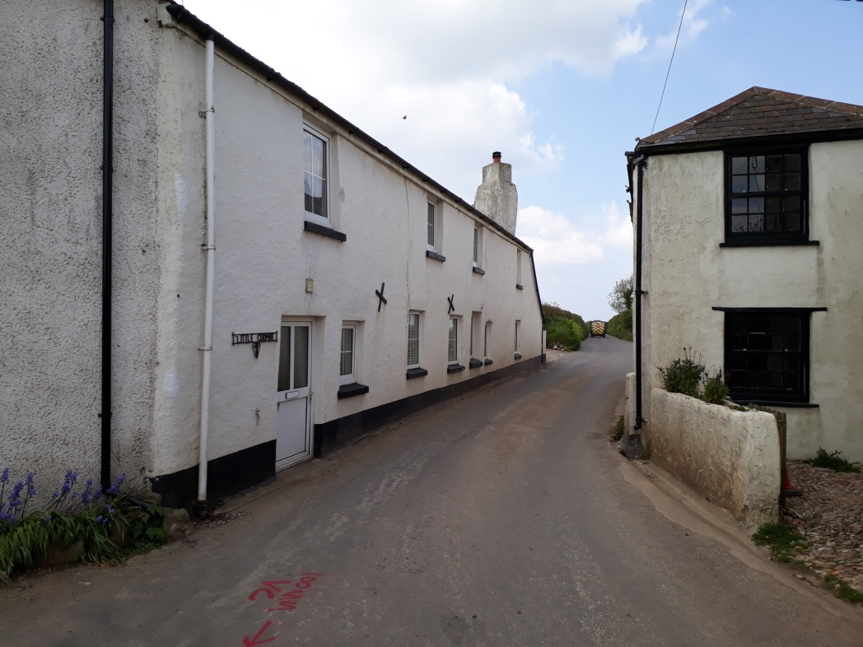
The road to Ringmore with the old grade 11 listed cottage adjacent to the pub and Little Coombe form a narrow passageway.
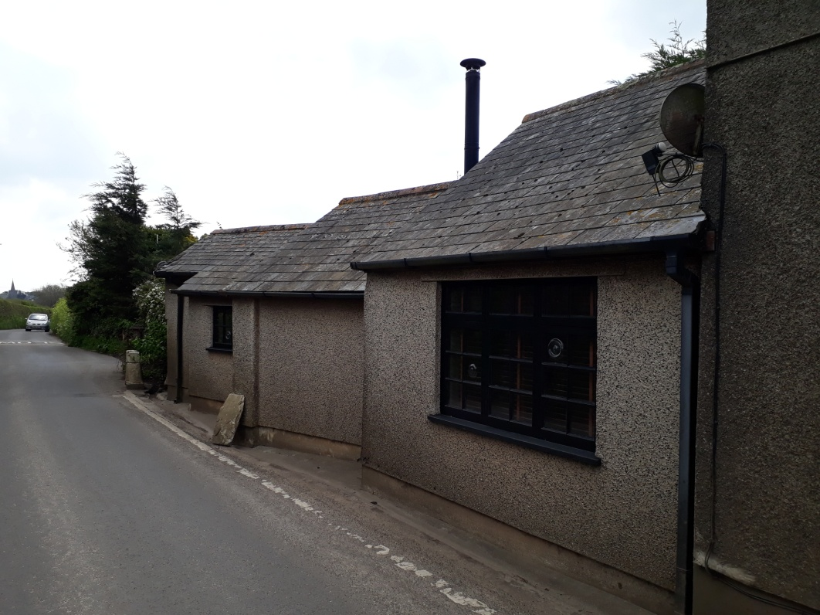
The historic Old Bakery on the road to Bigbury.
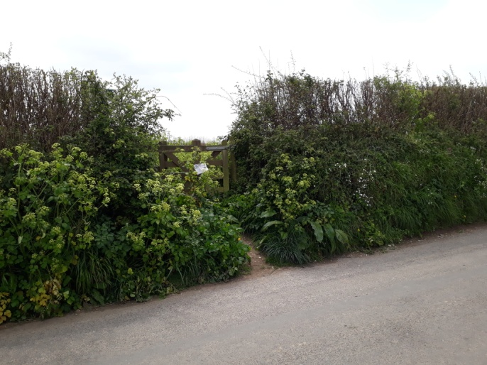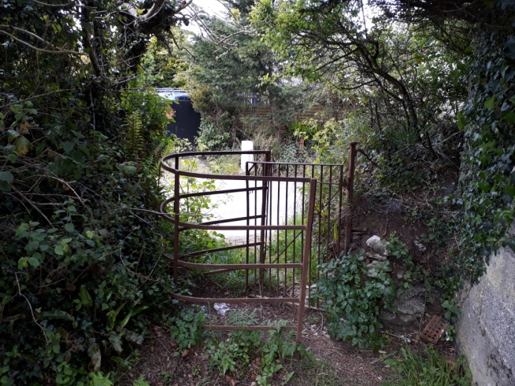
Access footpaths around the village with hedgerows providing wildlife sanctuaries.
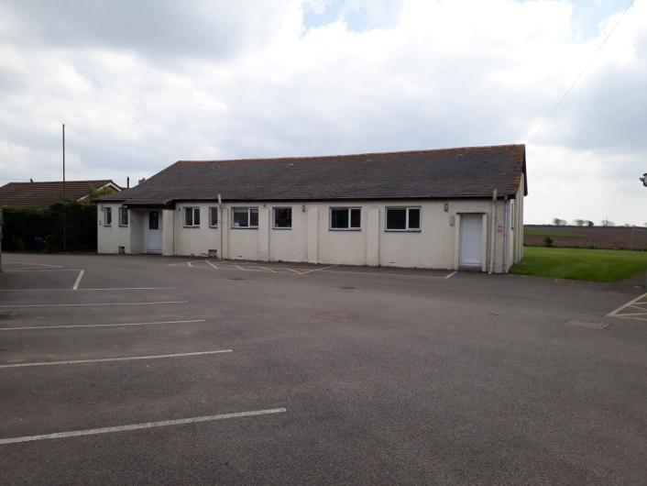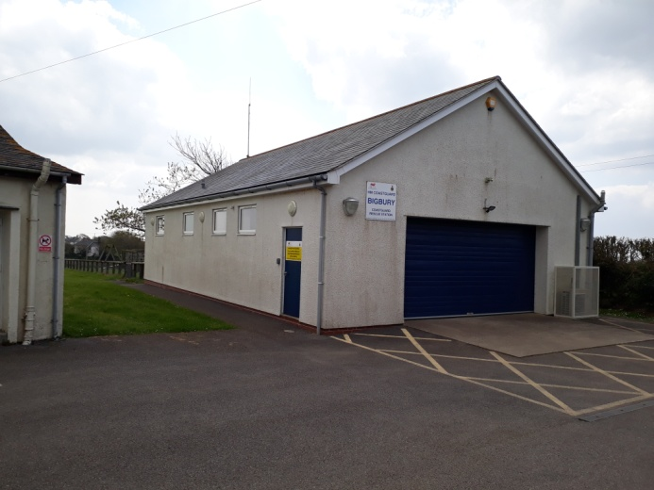
Bigbury Memorial Hall and coastguard station with car parking.
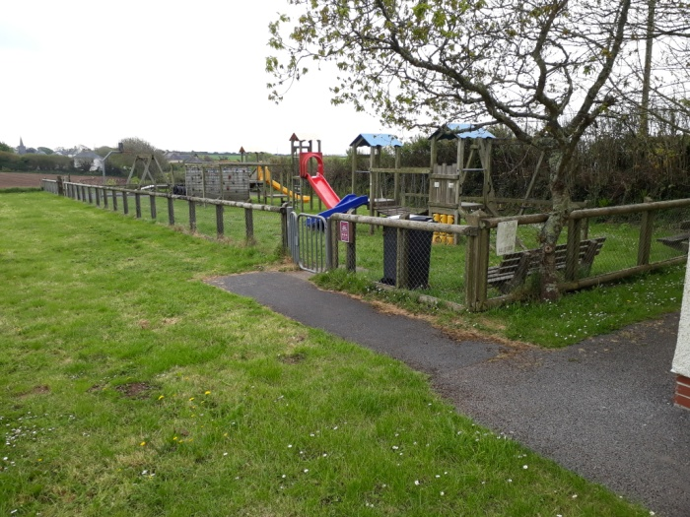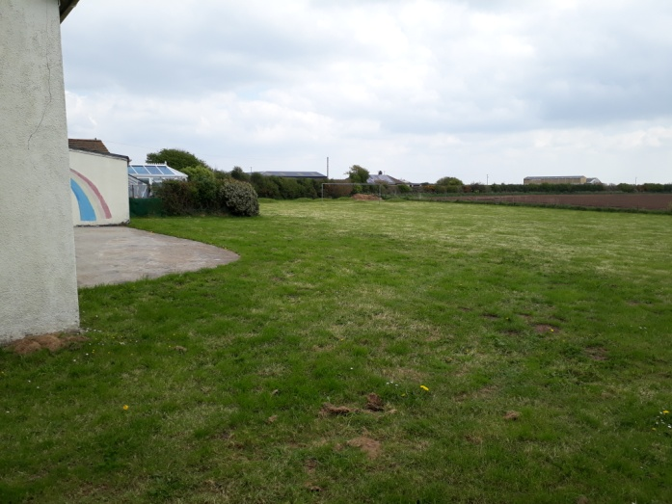
The childrens’ playground and football pitch to the rear of the village hall with open aspects to the fields beyond. Saxon remains have been excavated in these fields which are now protected.
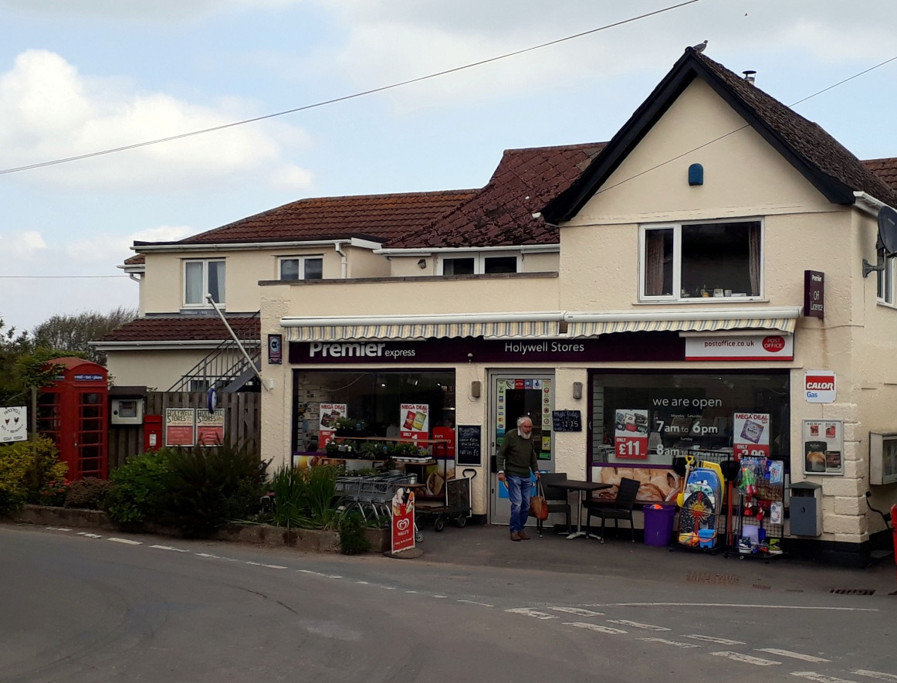
Holywell Stores with its post office, shop and telephone kiosk.
There are many Devon hedges around the village which need protection as they maintain thriving wildlife with many wild flowers.
Development Sites:
It has been identified that there is a requirement to accommodate approximately 10 new (mostly affordable) homes in the Bigbury Parish. The only sustainable area for development in the parish was considered to be St Anns Chapel and as such there were six sites identified by South Hams District Council as possible sites that the land owners were all prepared to sell.
These sites were analysed in detail by the BNP steering group and the pros and cons of each site were explained at a public meeting in the village hall. Each attending member of the meeting was asked to vote for their preferred site.
The preferred site identified is located behind the Holywell Stores car park running down to Holwell Farm.
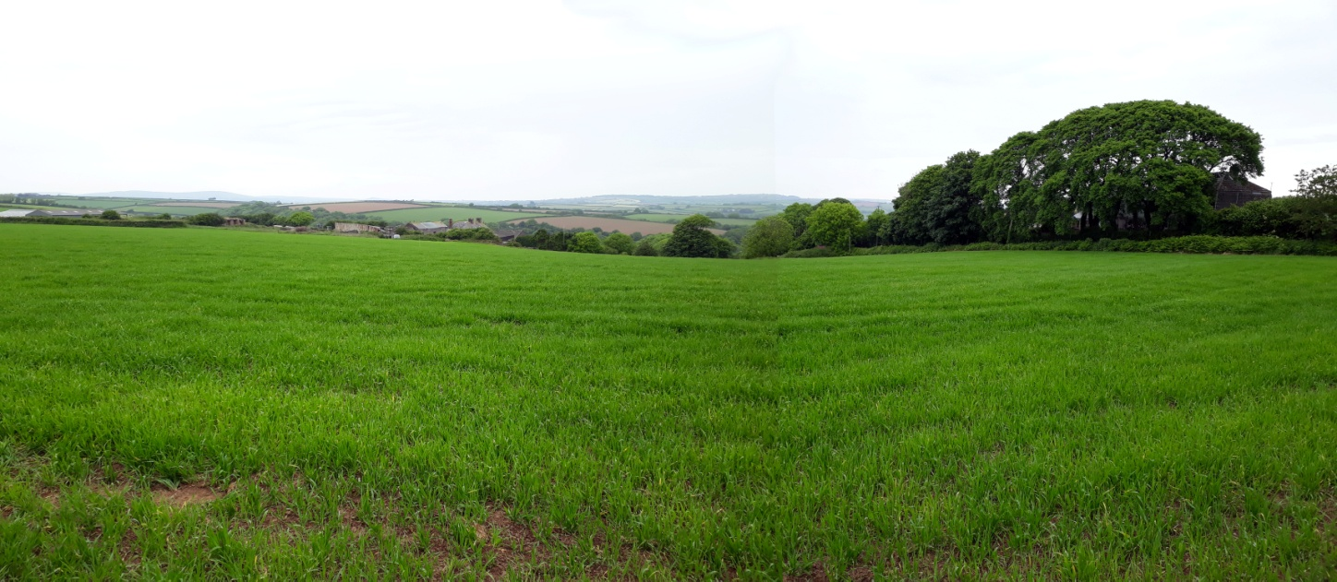
The view across the possible development site at the rear of Holywell Stores.

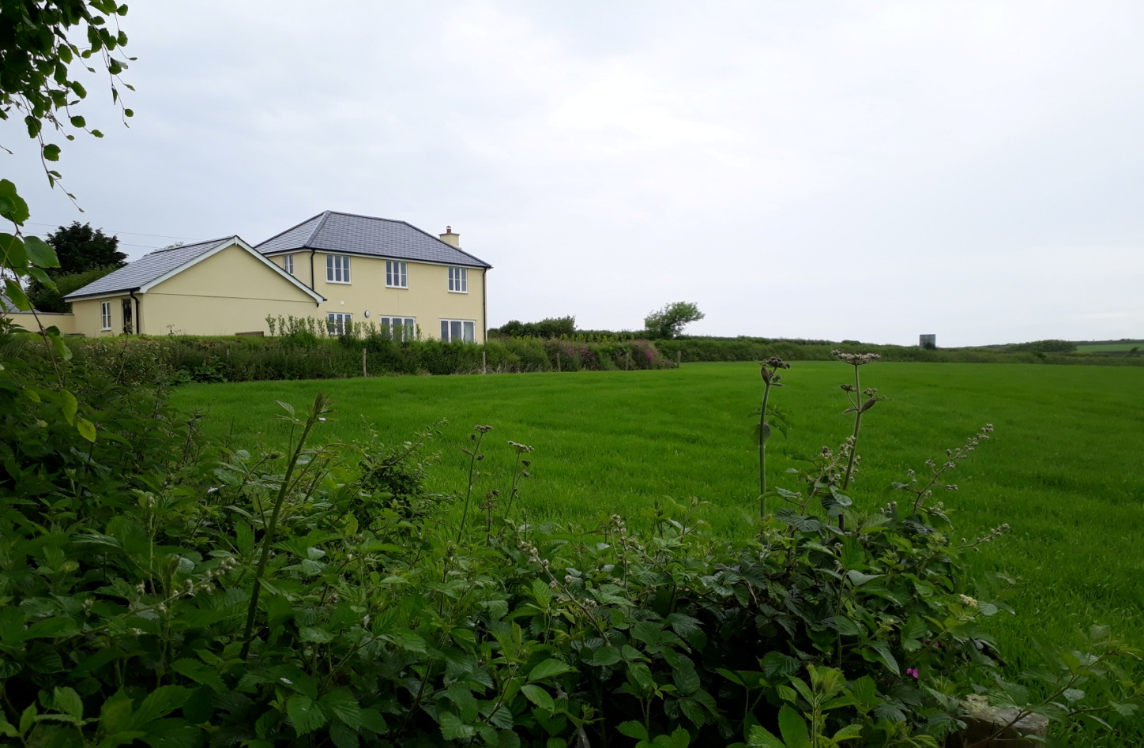
View across the rear of the new houses on the B3392.
A new road access would be built from the approach road into St Ann’s Chapel adjacent to the newly built houses on the B3392. Vehicles using this new access road would not increase the congestion at the main junction by the shop and Pickwick Inn.
A safe pedestrian route could be provided using the little used track between Holwell Farm and the Stakes Hill Road to access the Holywell Stores and school bus stop. Pedestrians would be able to walk through the Hilltop development to access the Memorial Hall, playing fields, skateboard area and children's playground.

New development should be small in scale, no more than two storeys, and use materials to match existing dwellings, painted rendered walls, painted timber windows and doors and slate roofs. The recently built terrace of three dwellings on the north side of the Ringmore Road (C252) provide a good example of modern design which fits in well with the appearance and character of the village.

