Ringmore & Bigbury Neighbourhood Watch Invites YOU!
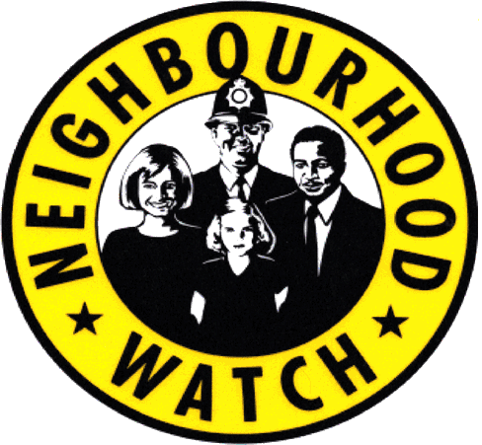
Your family, neighbour and guest are very welcome.
Fire Safety Presentation by Devon & Somerset Fire & Rescue Service
1400hrs Monday 30th October 2017
Bigbury Golf Club, Bigbury- on -Sea. TQ7 4BB by kind permission of the management supporting our Community. Golf club members most welcome.
To the benefit of residents of Bigbury, Bigbury on Sea, Challaborough, St Anne’s Chapel, Ringmore and all other outlying regions.
FREE Home Safety talk provided by Devon & Somerset Fire Service. Learn how to protect yourself, identify fire hazards and get practical one to one advice.
Attendees will be able to register for the follow up FREE service.
Devon & Somerset Fire & Rescue Service offer free Home Fire Safety Checks. The check takes no longer than five minutes after which you may be offered a home fire safety visit.
Also present your local Neighbourhood Police Pc Ryan Hayhurst and PCSO Warren Palmer along with your Neighbourhood Watch Co-ordinator. Your chance to meet and discuss in private any policing matters in this neighbourhood district.
Cllr Beth Huntley, ward Councillor for Charterlands will also be present.
This event, has been organised to allow for the Community to come together in a relaxed social manner. Refreshments available.
Come and support your Community, secure your home and FREE safety check.

