Bigbury-on-Sea layby / obsolete bus stop

The Parish Council, who own the layby, are looking to make this community asset a more attractive site for both locals and holidaymakers. We seek the views of the local community to ensure the concept and design meets the expectations of the residents.

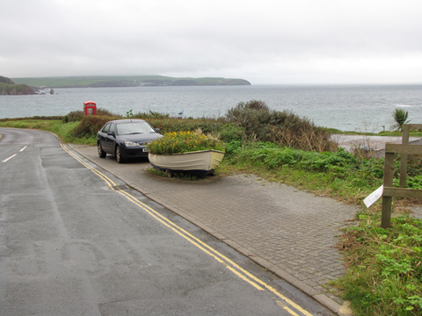

All suggestions will be considered and as the site is to be used in a different way, the Parish Council would like to implement the changes by Spring 2018.

The outline timetable is as follows:

December 1st 2017 - ideas and suggestions are to be submitted to the Parish Clerk. These can be provided in any format i.e. e mail, letter etc. and sketches are welcome.

December 13th 2017 – ALL ideas and suggestions received will be discussed at the Parish Council meeting and a decision will be made as to which option, if any, will be implemented.

Clerk contact details:

R Matthews, 10 Lower Brook Park, Ivybridge, PL21 9TZ
Clerk.bigburypc@gmail.com

