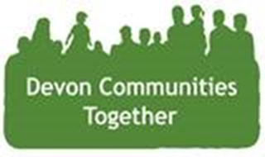
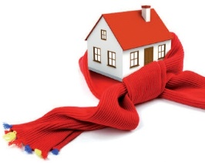
Western Power Distribution Affordable Warmth

Affordable Warmth aims to reduce fuel poverty across Devon, Cornwall and the Isles of Scilly, by working with members of the community to reduce their fuel bills and to increase their knowledge and confidence about using energy wisely in the home. We Can Offer:
- Home visits.
- Home assessments to identify ways to make them more energy
Efficient.
Help to find the best value energy tariff.
- Information about the use of smart meters.
- To contact the energy supplier where appropriate and advocate on customers behalf.
- To identify other help you need and to find others to help you.

If you or someone you know needs help to lower their
Fuel bills or make their home more
Energy efficient, get in touch:

If there is an opportunity to speak
at one of your meetings please contact Martin or Katherine

Please Call: 01392 248 919 Ext 7141 / 7140
Email: martin@devoncommunities.org.uk
katherine@devoncommunities.org.uk
Alternatively, visit our website: https://www.devoncommunities.org.uk/western-power-distribution-affordable-warmth

