CPR & Defibrillator Training
1100hrs on Saturday 21st April 2018 at the WI Hall, Ringmore. ALL ARE VERY WELCOME.
Training provided by Nigel Toms the unpaid local volunteer Community First responder for South West Ambulance Service.
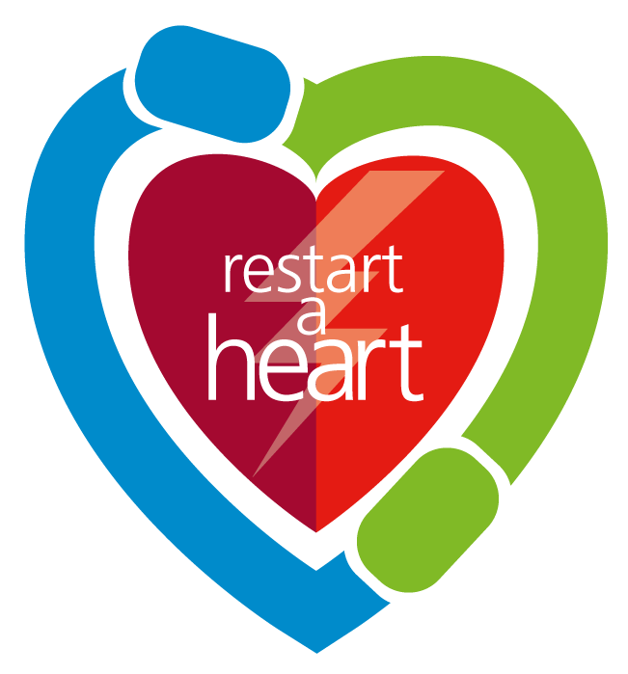
Restart a Heart Over 3,600 people are resuscitated by ambulance staff every year in the South West because they suffer a pre-hospital cardiac arrest. For every minute that passes once in cardiac arrest, a person loses a further 10% chance of survival, and with this dramatic loss in chance of survival, there is a need of a defibrillator every 4-5 minutes walk. Without doubt this availability would improve cardiac arrest survival rates throughout the South West.
A defibrillator is a device used to give an electric shock to help restart a patients heart when they are in cardiac arrest. If there were more public access defibrillators, more people could get a life-saving shock as quickly as possible, ahead of an ambulance, which would assist in giving them the best possible chance of survival.
When someone suffers a cardiac arrest, the heart stops and blood is no longer being pumped around their body. The longer they go without emergency life-support, the harder it is to restart their heart. This is where you and your community, organisation or business could make a difference.
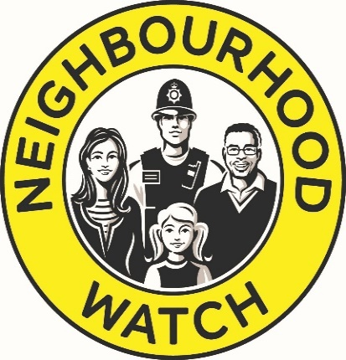Also in attendance - your local Community Beat Officers.

