Burglary at Bigbury on Sea.
Overnight, between Thursday (31/05/18) and Friday (01/06/18) thieves have broken into a container at Bigbury Beach and stolen a Mariner 35hp outboard engine which was owned by the RNLI.
The engine was affixed to the inshore RIB which the RNLI Lifeguards used to patrol the beach and save lives.
This is a copy of the engine which was stolen from the RNLI burglary. Note the modification. Even if this extra metal part has been removed it can still be identified by the bolt holes.
If you see,or are offered this engine then please call 101 quoting CR/47682/18.

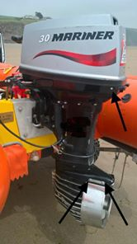

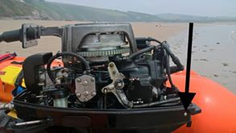

If you have any information or can help us in any way with this investigation then please ring 101 or email 101@dc.police.uk quoting crime report CR/47682/18
STAY ALERT WHEN YOUR PHONE RINGS AND IT’S A COLD CALL – Best advice simply hang up! See below.
"Courier" fraud ALERT
The National Fraud Intelligence Bureau (NFIB) has noted an increasing number of reports of courier fraud submitted by the public through Action Fraud.
Please read this advice and share it, and talk to relatives or friends who are not online and who won't see this post, as this is a telephone based fraud and the fraudsters are very convincing.
Fraudsters contact victims by telephone claiming to be a police officer or bank official. To substantiate this claim, the caller might be able to confirm some easily obtainable basic details about the victim such as their full name and address.
They may also offer a telephone number for the victim to call to check that they are genuine - this number is NOT genuine and simply redirects back to the fraudster who pretends to be a different person. After some trust has been established, the fraudster will then, for example, suggest;
- Some money has been removed from a victim’s bank account and staff at their local bank branch are responsible.
- Suspects have already been arrested but the “police” need money for evidence.
- A business such as a jewellers or currency exchange is operating fraudulently and they require assistance to help secure evidence.
Victims are then asked to cooperate in an investigation by attending their bank and withdrawing money, withdrawing foreign currency from an exchange or purchasing an expensive item to hand over to a courier for examination who will also be a fraudster. Again, to reassure the victim, a safe word might be communicated to the victim so the courier appears genuine.
At the time of handover, unsuspecting victims are promised the money they’ve handed over or spent will be returned to them - but in reality there is no further contact and the money is never seen again.
Remember, your bank or the police will NEVER:
- Phone and ask you for your PIN or full banking password.
- Ask you to withdraw money to hand over to them for safe-keeping, or send someone to your home to collect cash, PIN, cards or cheque books if you are a victim of fraud.
Don’t assume an email or phone call is authentic - Just because someone knows your basic details (such as your name and address or even your mother’s maiden name), it doesn’t mean they are genuine. Be mindful of who you trust – criminals may try and trick you into their confidence by telling you that you’ve been a victim of fraud.
Stay in control:
If something feels wrong then it is usually right to question it. Have the confidence to refuse unusual requests for personal or financial information.
Report it immediately if you think you have been a victim of fraud:
www.ActionFraud.police.uk or 0300 123 2040.
Stay safe.

