FRIDAY 22 FEBRUARY AT 7 PM
BIGBURY MEMORIAL HALL
£10 pp inc pasty plus bottle of wine per team of 6. Bring own glasses & cash for raffle Tickets: FIONA DUKES 07778 263827 HOLYWELL STORES St. Ann's Chapel
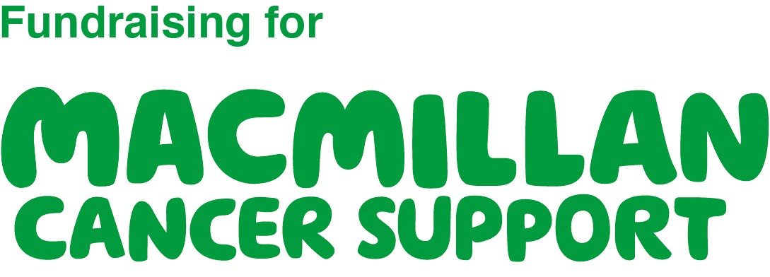Organised in aid of Macmillan Cancer Support, registered charity in England and Wales (261017), Scotland (SC039907) and the Isle of Man (604). Also operating in Northern Ireland.

