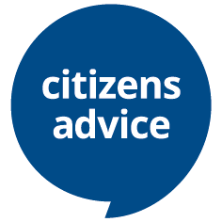

Citizens Advice South Hams seeks new Trustees
Citizens Advice South Hams plays a vital role in our local community providing free, independent and impartial advice to clients on issues such as debt, benefits, fuel poverty, housing and employment. Our trustees ensure that the charity is well managed and that resources are utilised effectively and appropriately.
Trustees devote time, commitment and experience to carry out this voluntary role, which normally requires attendance at formal meetings once a month and participation in informal meetings and subgroups.
We seek applicants with previous experience in the commercial, public or voluntary sectors and welcome applications from all sections of the community. We are particularly keen to recruit those who may have used our services. Training and support will be provided.
If you have the enthusiasm to help us steer and develop this essential advice service, please write to Rob Austin, Citizens Advice South Hams, Follaton House, Plymouth Rd, Totnes, Devon TQ9 5NE or email trustees@southhamscab.org.uk or telephone 01803 861241 for an informal discussion.

