WALE

THE PRINCE OF WALES AWARD

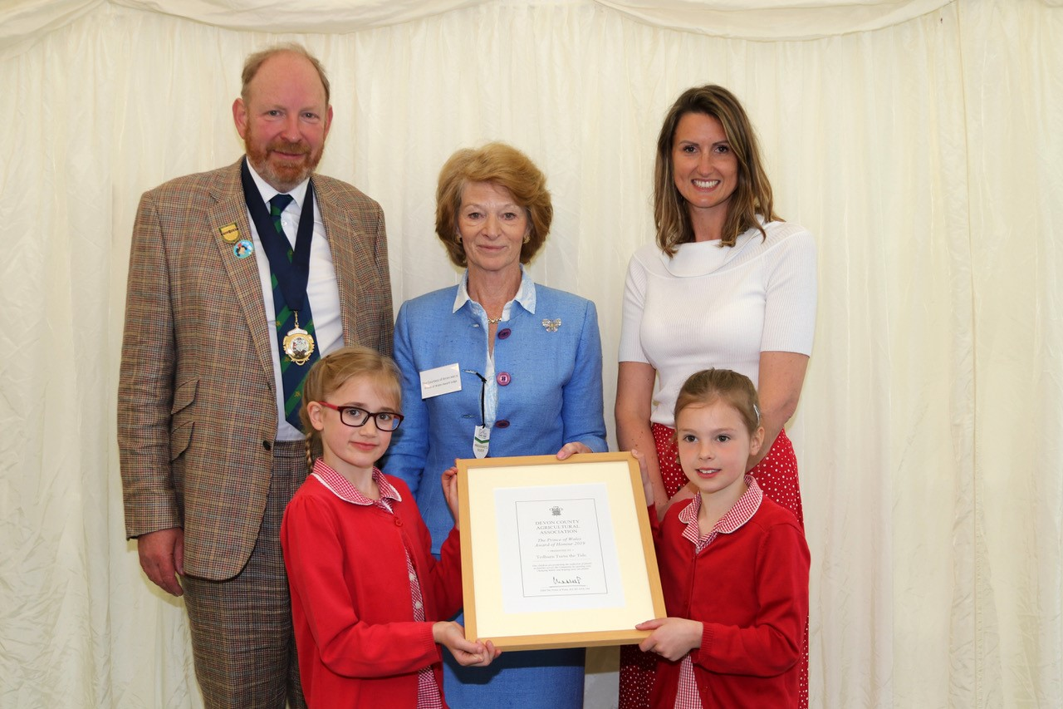
ENTRIES CLOSE
29th March
1st Prize
£1,000

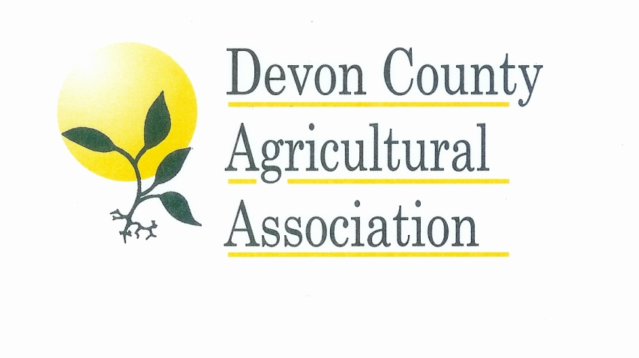

This Award is open to community organisations including schools and small farm business diversification projects which are seeking to educate and involve young people in sustainable initiatives.
ENTRIES CLOSE
15TH MARCH

THE PRINCE OF WALES AWARD

Those who consider that their work might fulfill the criteria should enter by completing the enclosed entry form and answering the questions on a supplementary form or visit our website www.devoncountyshow.co.uk. The award will be presented to the group which has, in the Judges estimation following a visit to the shortlisted candidates, made the most outstanding contribution to improving the lives of their community. The Award carries with it a framed certificate and a cash prize of £1,000 from His Royal Highness the Prince of Wales, which the winning group must use to further their community initiatives.

RULES OF THE COMPETITION

- Open to organisations in Devon only.
- The information supplied will not be divulged as per GDPR.
- Preliminary selection will be made using the information supplied by the competitor.
- The selected competitors will be informed during the first week of April 2020.
- The judges will visit the short listed entrants during the third week of April 2020.
- The panel of judges will consider the general criteria using the information supplied in conjunction with their visit. Judges will be from The Duchy of Cornwall and the DCAA.
- The presentation of the Award to the winner of the competition will be made at the Devon County Show on Friday 22ndMay 2020.

ENTRIES
CLOSE
29TH MARCH

Previous winners of the Prince of Wales Award include:

2019 Tedburn Turns The Tide (Tedburn St Mary Primary School)
2018 Wynstream Primary School
2017 The Crediton Community Bookshop and the Children’s Summer Club
2016 Park Life Heavitree
2015 Swimbridge Jubilee Hall
2014 Newton St Cyres Community Support Group
2013 Bickington Village Trust
2012 Sustainable South Brent

As a result of winning the Prince of Wales’ Award for our Plastic Recycling Project, the children’s and community’s awareness of plastic use has been greatly increased. We now have a strong Eco-Council who are working towards achieving the Eco Bronze and Silver Awards. With the money from the Award we have been able to purchase hand driers for all the children’s toilets in school, thus removing the use of paper towels and increasing our sustainability.

Tedburn Primary School
(2019 Winner)

It has meant so much to our children and their families to have their very hard work rewarded. They are even more inspired and motivated to learn within the natural world and respect and preserve the environment for themselves and future generations. The prize money meant we could fast track our plans to build the pollination project which is now an environmental haven and beautiful outdoor learning space.

Wynstream Primary School
(2018 Winner)

We are very proud of this recognition for our schools outreach programme, and the talented and passionate team of volunteers who make this happen. This award will enable us to deliver more author visits and literary events, and to inspire in children a love of books and reading.

The Crediton Community Bookshop and the Children’s Summer Club based in Barnstaple.
(2017 Winner)

THE PRINCE OF WALES AWARD

Please complete the below entry form below along with the information and questions about your project on a separate sheet max on 2 x A4 sheets to be attached/supplementary information to be included.

Name of Project ___________________________________________________

Contact Name ____________________________________________________

Address (including Postcode) ________________________________________

Telephone Number ________________________________________________

Email Address ____________________________________________________

To be completed on a supplementary sheet and attached to the forms:

- Name and Address of Project (Including Postcode)
- Website
- Facebook
- Twitter
- Aim and Objectives of your project
- What has been the highlight of your project to date?
- Community involvement – who are they and how do they benefit from the project?
- Future plans for your project
- Any other information you would like to tell us about your project
I confirm that each and all of the particulars on this form are correct to the best of my knowledge and belief and I accept the DCAA’s Rules of the Competition

I confirm that I am eligible to compete in this competition. I hereby undertake to abide by the rules and the regulations issued but the DCAA.

Please return to Lisa Moore:

Devon County Agricultural Association

Westpoint, Clyst St Mary, Exeter, Devon, EX5 1DJ

Email: lisamoore@dcshow.org

