Archaeological Investigation at St Ann’s Chapel
Presentation by South West Archaeology
At 7pm on 13 October 2021 in the Memorial Hall

South West Archaeology are currently carrying out a site investigation of the land to the south of the road to Ringmore, which is soon to be developed to provide 9 new houses.

It is understood that a large part of this area was subject to Late Stone Age activity, with this site being part of a Neolithic settlement.

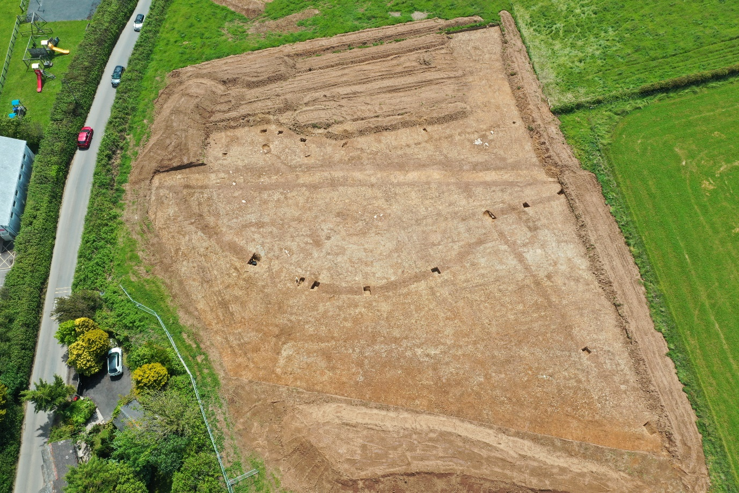

Dr Sam Walls of South West Archaeology, who has been supervising this investigation, has kindly agreed to give a presentation to the local community at the Memorial Hall on Wednesday 13 October 2021 at 7pm, prior to the October Parish Council meeting.

Dr Walls will be advising the local community about the findings of the investigation and hopefully he will bring along some of the exhibits.

This presentation is free and can be attended by anyone who is interested in finding out more about the history of the area.

