Bigbury on Sea Village Study for Bigbury Neighbourhood Plan Steering Group.
Introduction and Historical Context
Bigbury on Sea is a relatively recent development on what had been farming land in the nineteenth century. There were few buildings then other than Folly Farm, Warren Cottage and the fishing canneries. In 1908, the enterprising Bigbury Bay Land Company bought the area from the Cleveland estate and their planned holiday village was quickly constructed. By the Great War small hotels and holiday bungalows with rooms to let were already in place, and in addition day trippers came from Plymouth by steamers. The advent of motorised transport subsequently placed Bigbury on Sea firmly on the tourist map, and the Pilchard Inn and Barden's Tea Rooms provided food and drink. The golf course amenity (which lies between Bigbury on Sea and the village of Bigbury) was developed in the early 1930s, as was the Art Deco Burgh Island Hotel, which remains the iconic view of the South Hams.
Although some of the original 1910s chalet style buildings remain, the village has continued to evolve. In the 1960s and 1970s the desire to live, or dare it be said, to retire by the sea encouraged many bungalows to be built both here and overlooking Challaborough Bay. For holidaymakers who wished to enjoy this special Area of Outstanding Natural Beauty there were still plenty of amenities - Folly Farm, the Henley Hotel and even a Youth Hostel provided varied accommodation, the Bay View Cafe and Tom Crocker Inn provided sustenance, and the Post Office/Shop had provisions - only the farm and hotel (with its Pilchard Inn) remain. The desire for second home ownership and for homes to let has resulted in further building developments of various architectural styles from the 1990s onwards. However, the buildings have all been within the confines of the village boundary. At present the existing amenities are tourism orientated businesses, located around the main car park and beach; these provide locals with some opportunities, as does servicing the letting accommodation, but most of the associated workers come from outside the area.
Layout of village
You know you have reached Bigbury on Sea, not only by the boulder announcing a welcome, but also by the splendid view you have over the village from the top of Folly Hill, funnelled by the green and agricultural rolling slopes down to Burgh Island and its Art Deco hotel, surrounded by sea and beaches. The B3392 is the only road in and out of Bigbury on Sea. The village effectively falls into two parts, with linear development (outside of the village development boundary) following the hill and coastal cliffs down into the main grid based area, within the boundary enclosed by the beaches and fields.
Photo below: The view on reaching Bigbury on Sea. At the top of Folly Hill stand Mount Folly Farm, with the barn conversions of Avon Court lining the route on the left, and on the right fields used in summer as the farm’s camping site and car park.
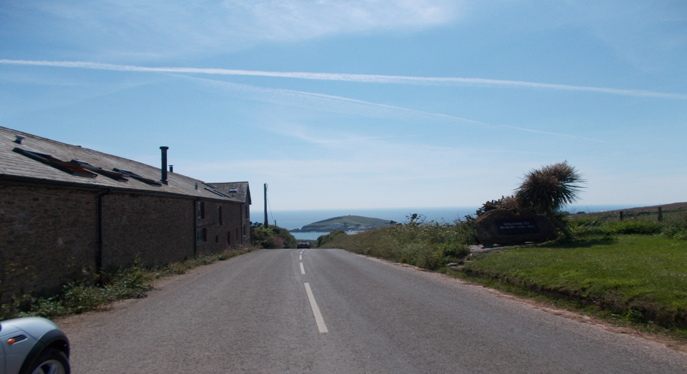
Following the hill downwards, on the left is a run of detached houses and bungalows of the 30s to the 2010s set back off the road in large plots. Avon Quillet, a block of flats, and the Henley Hotel both border the road as it narrows and curves slightly, before a left turn off Folly Hill into the cul de sac called Clematon Hill. Here again on the left continues a short line of individually styled, almost all detached, houses and bungalows of various ages, more closely spaced with smaller grounds. All the afore-mentioned properties are on the cliff edge with uninterrupted views over Bantham and coast beyond. On the right hand side of Folly Hill are fields used for grazing and crops, ending in a field virtually opposite the Clematon Hill access, used for grazing in winter and as parking for tourists in summer.
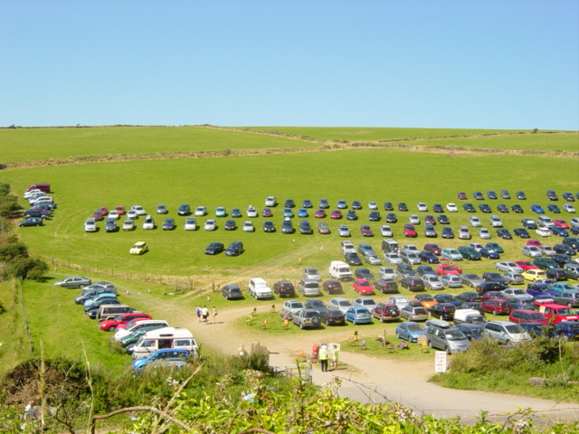
At this point the village development boundary starts – see map. Folly Hill continues to run down toward the sea. On the right are six bungalows built in the 60s, set back off the road with large front and rear gardens, and fields behind. They have low-pitched tiled roofs, rendering, stone and timber cladding finishes to the variously renovated and extended properties, but each considerately staggered in their plots to allow each bungalow views of the sea and Burgh Island. A large detached house sits on the corner of a cul de sac, off which are accessed 2 further bungalows stepped up on the slope to allow for sea views, and at the end of which lies a footpath leading to other parts of the village. These afore-mentioned properties are fronted by the only length of pavement in the entire parish! On the opposite side of the road is the tract of green warren land called Clematon Hill, owned by the National Trust, and over which the public can meander to enjoy wonderful views over the coast and village.
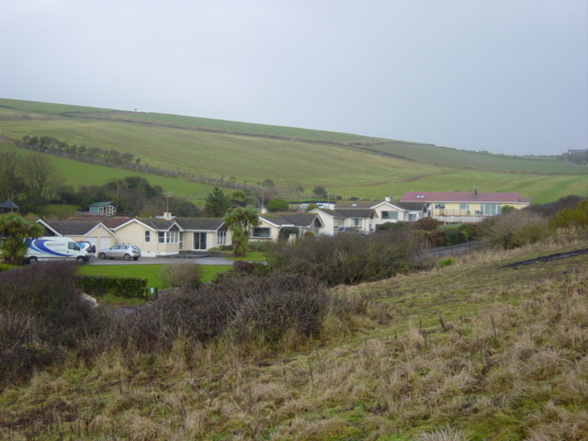
Folly Hill changes name at this point to Marine Drive, marking the start of the grid pattern that forms the layout of the rest of Bigbury on Sea. (see map).
To the left of Marine Drive, and outside of the development boundary, lie the main car parking for tourists, the Burgh Island Causeway apartments, the Warren, and the slipways to access the beaches. The beaches are a huge draw throughout the year for visitors and locals alike. They are some of the first sandy beaches east of Plymouth, loved by families, dog walkers, and water sports participants, although there are dangerous rip tides to be aware of due to lying at the mouth of the River Avon. At low tide you can walk across to the privately owned Burgh Island, with its Grade 2 listed hotel and 13th century Pilchard Inn, and take the footpaths open to the public on the west side of the island up to remains of the Huers’ Hut, with magnificent views over the coast. At high tide the crossing is made on the famous Sea Tractor. Although the beaches fall within the AONB, surprisingly the island does not, and recent planning approval for the construction of a modern annexe to the hotel has caused much controversy, not just locally.
Photo below of Burgh Island, Pilchard Inn on front RHS and Huers’ Hut on sky-line.
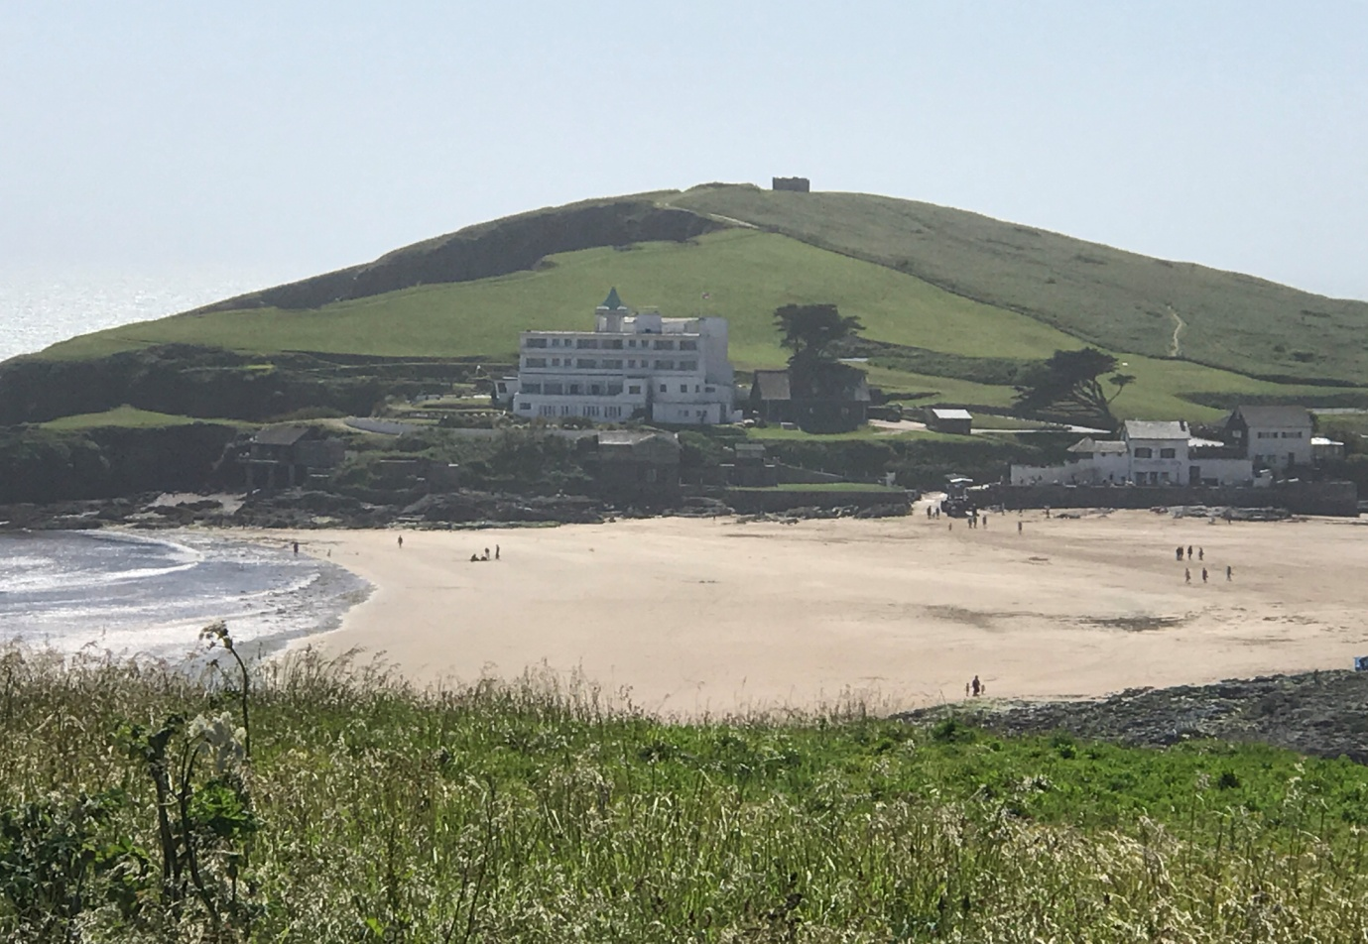
The car park area (rented by SHDC) hosts a cafe, ice cream kiosk, surf school, beach shop, coastguard station, public toilets and recycling banks. Problems with regard to coach parking space need to be addressed, to avoid dangerous loading and parking issues on Marine Drive and bottom of Parker Road. The Plan Questionnaire raised a 33% response to the consideration for secure bicycle parking on the main car park. There is concern at the degradation of the Warren due to its use as an overspill car park, and interest in keeping this as an historic and recreational asset for the village. At the end of the Warren, Marine Drive follows the curve of the cliffs, with housing on both sides of the road, (photo below) before petering out into the footpath that leads down the cliff edge into neighbouring Challaborough.
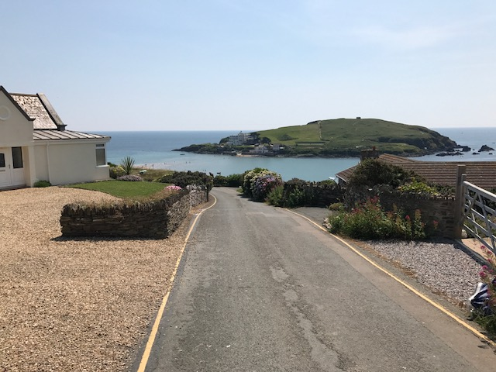
There is a green edge to the remaining sides of the Bigbury on Sea development boundary, formed by properties backing onto agricultural fields. A footpath leads off from the top of Parker Road across the fields, and a short stretch of tree-lined footpath, known locally as Badgers’ Walk, links the east end of Cleveland Drive to the east end of Ringmore Drive and down into the Folly Hill cul de sac mentioned earlier. The Tree Warden has stated that the trees should remain, but be pruned back occasionally to keep the footpath accessible. Photo of Badgers’ Walk below.
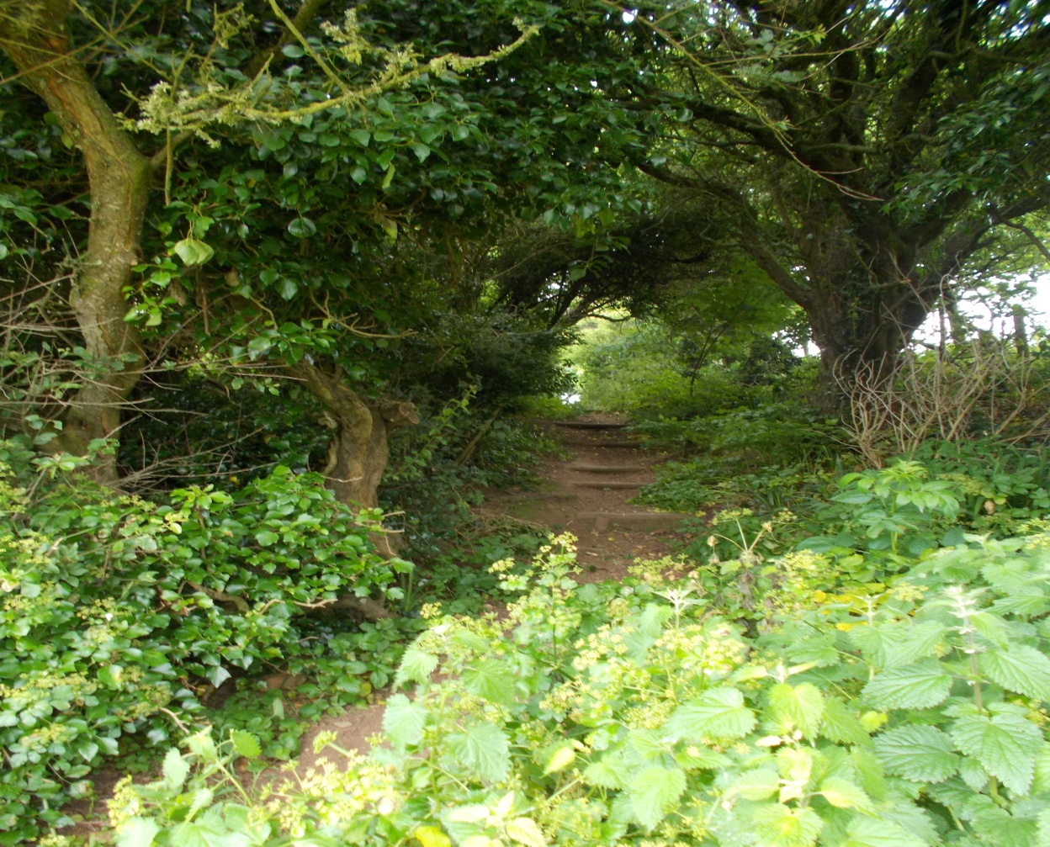
Property Types and Designs
Returning to the grid layout of Bigbury on Sea, the original plots on land formed by the various intersections were very generous, accommodating large houses, bungalows and hotels, well separated from each other. This also created an impression of green space throughout the village viewed from the beach and Clematon Hill, which is in danger of being lost. Properties were constructed using the slopes leading away from the coastline into agricultural fields to maximise views for all properties. It has to be said that the vast majority of smaller properties were built on tight budgets as holiday homes for Plymothians, with poor quality of materials and design. Over the years there has been a cyclical pattern of ownership – from mostly holiday homes, to people retiring and living permanently in the village, and now as people die, over 50% of properties have become again second homes / holiday lets. On the positive side these create more employment opportunities for supporting services / businesses with money coming into the wider area’s economy. On the negative side village shops and businesses within the parish have closed, unable to cope with seasonality and price competition (eg from supermarket deliveries), and there is added traffic and road deterioration as well.
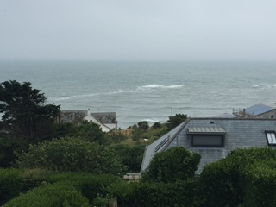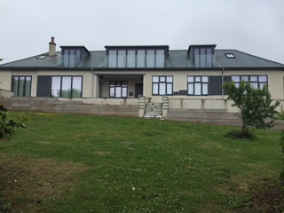
Above left, photo showing the use of slopes to maximise views for all; above right, a recently much modernised 1930s bungalow, originally colonial in style and still set in very large grounds. Below, are two older bungalows along Marine Drive, again in large plots.
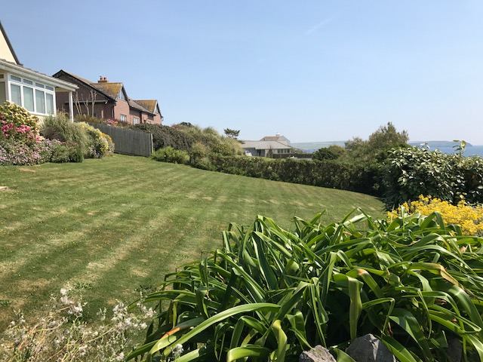
Photo below, the Korniloff Residential Home, originally a hotel for holidaymakers in large grounds with tennis courts to the side, land which was sold off some time ago for the construction of a bungalow.
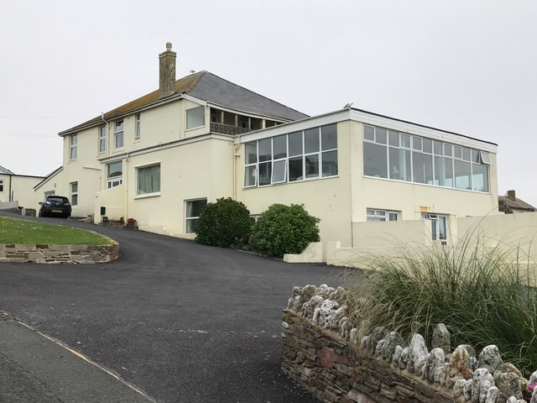
During the last 30 years, gardens have been sold off for infill development, and whilst the build quality has improved in line with regulations, property prices have increased steeply, and single bungalows are now more often replaced by two 2 storey properties, particularly so since the turn of the century. Previously a walk round the village revealed a range of characterful, differing, even quirky building styles.
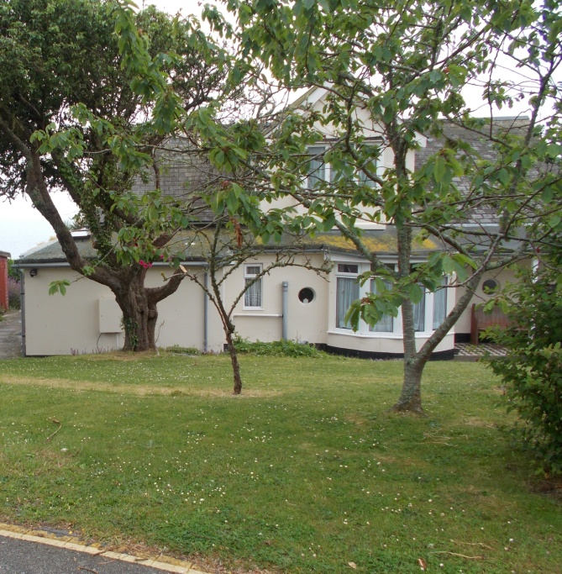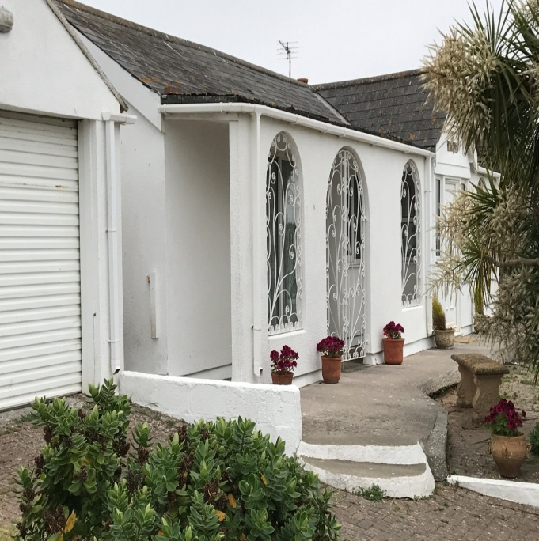
Above left, a much extended original bungalow on a large plot between Marine and Ringmore Drives. Above right, an original chalet from 1910 with additional front open porch. Below left, a large 1930s house, with in the foreground a chalet built along the road wall and a wooden chalet to the right. Below right, a 80/90s bungalow incorporating brickwork and leaded style windows, unusual for the area.
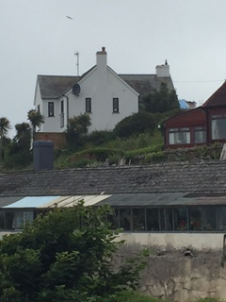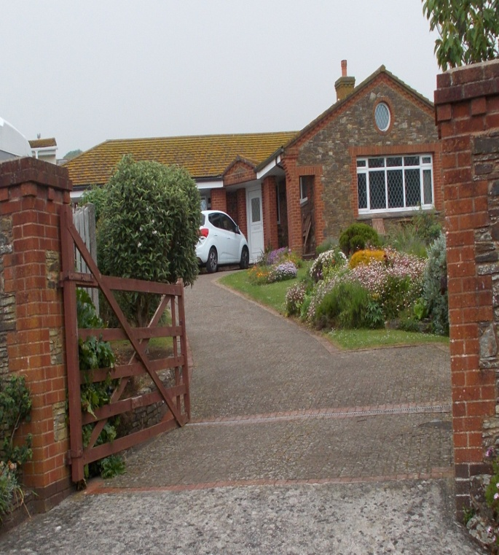
These original and older properties are being replaced by a more uniform style of ‘New England coastal’ development – two storey, upside down layout properties with a larger footprint and scale than previously on site, large areas of plain glazing, slate/zinc roofing, timber cladding, glass and stainless steel balconies and terraces, reduced green gardens and garaging, more hard standing for open parking, hard landscaping and extra decked areas. The three photos below show new builds that replaced single bungalows on large plots. The first shown added to a run of builds down from the top of Warren Road, each in turn blocking views of property behind.
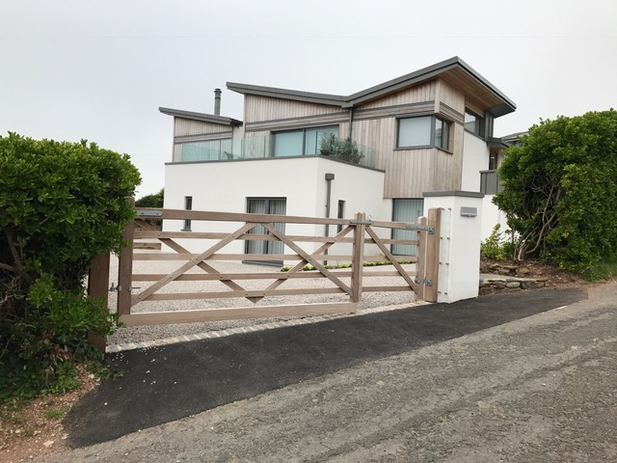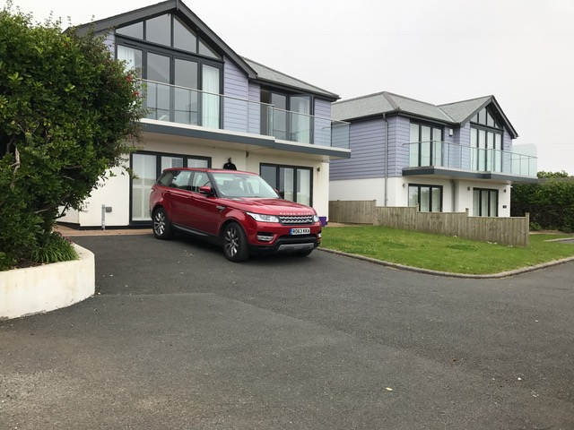
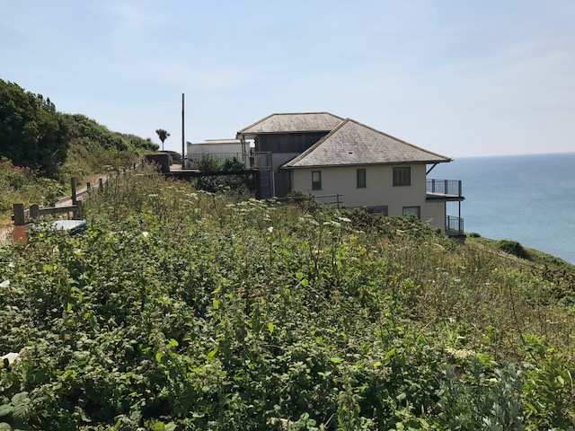
Considered individually there is nothing wrong with such a style/design of property, but much depends on the context of its location. Sometimes the contrast between older and newer properties is striking, even incongruous.
Some of the properties along the cliffs on both sides of the village have suffered from serious coastal erosion requiring in some cases the shoring up of properties as well as the reinforcement of the cliff faces with stone gabion walls which can look unsightly. New development including extensions to the footprint of existing properties on sites likely to suffer from future coastal erosion should be avoided if this would cause any potential danger to future occupants or result in unsightly mitigation measures.

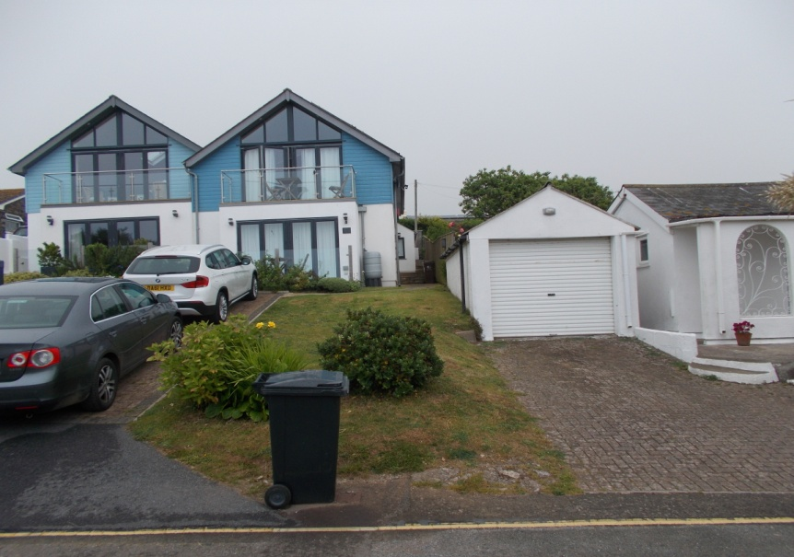
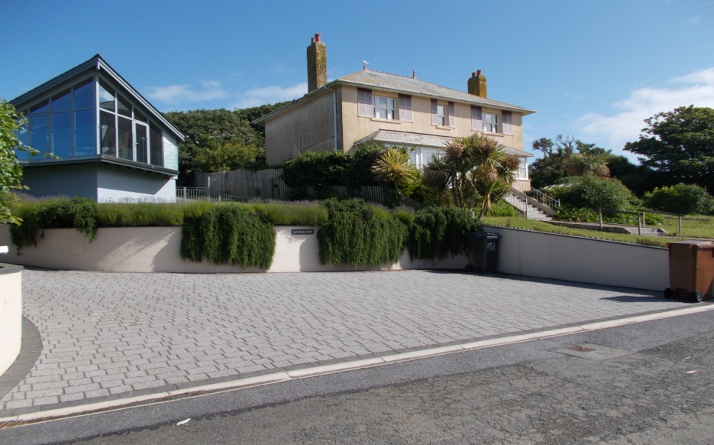
Photo below: Properties along Marine Drive opposite the Warren, part of a streetscape of bungalows which do not affect sea views from properties in the roads behind .The 2007 built bungalow in the foreground is generally considered by locals a good example of maximising site potential without spoiling views for others behind, modern but not out of place.
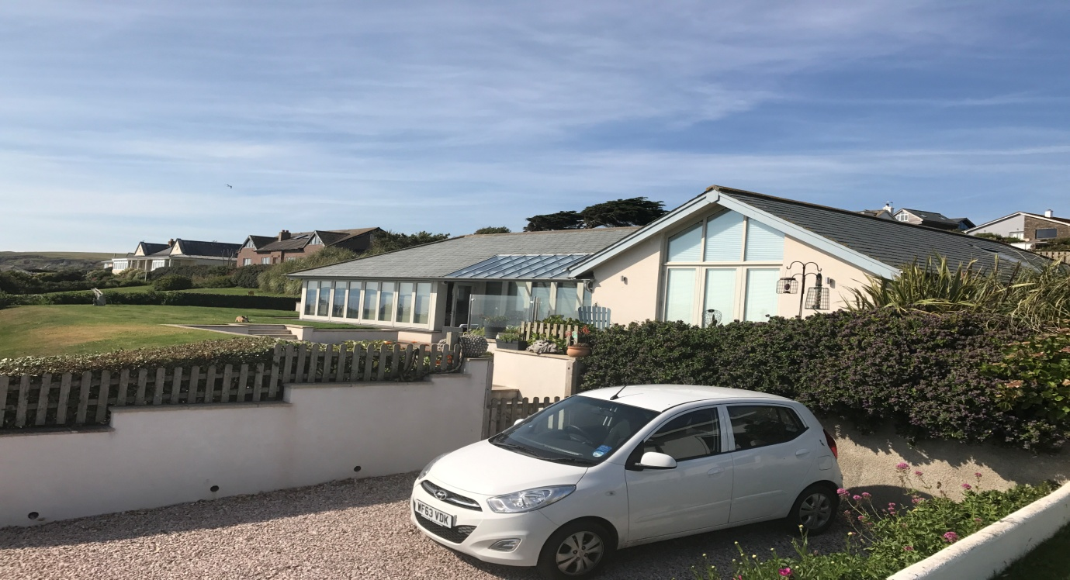
The property shown below was developed from a small bungalow, part of which remains as the middle section, into what could be seen as a large dominating mass on its Ringmore Drive plot, between two more architecturally traditional properties.
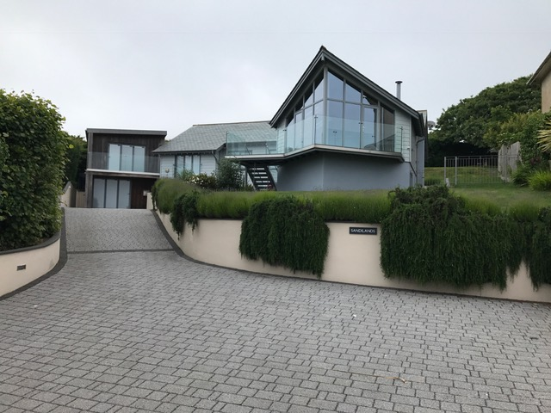
It also has to be acknowledged that some properties have been ‘land banked’ and allowed to fall into very poor state of repair, to the detriment of neighbouring properties and the image of the village overall. Means need to be identified of encouraging owners of such properties to at least maintain, if not make better use of, their plots. The property below has been left untouched well over ten years; a timber style building, it apparently won awards when first built. It occupies a large plot between Marine and Ringmore Drives.
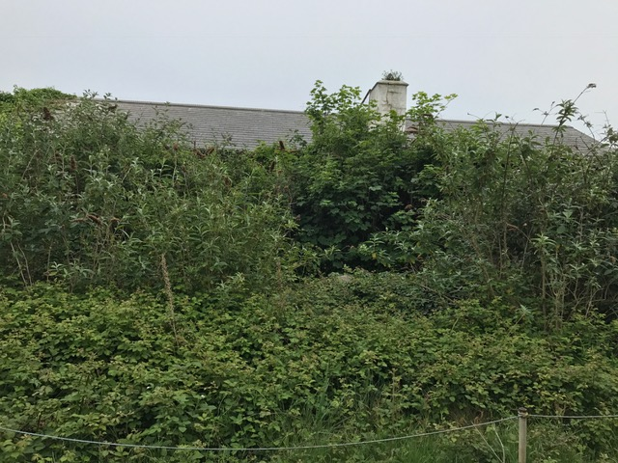
Proposals for Future Development and Design Policy
Concern is growing amongst all owners about an attitude amongst incoming owners and developers showing a lack of consideration for neighbours and the area in general, in order to maximise profit on a site. The continuing situation regarding the application to demolish Warren Cottage and the Bay View Cafe, (apparently the oldest house in the village and the site of a school in the war), for a development of four modern houses, on what is considered a visually and historically important site in the village, bears witness to this. The Bay View Cafe has now been registered as an Asset of Community Value, which affords time for further thought on this development. Photo below of Warren Cottage and Bay View Cafe, now empty.
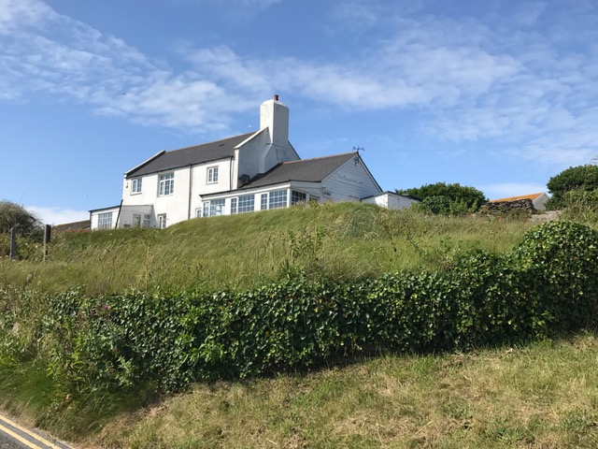
The Plan Questionnaire elicited responses where 49% of respondents thought new builds should be in keeping with existing buildings and sympathetic to the surrounding environment, and 37% felt views and privacy should be respected. 34% wanted ridge heights maintained and 11% did not like to see two to four properties replacing one. These answers reflect strong opinions that some restraints are required to ‘rein in’ the seemingly constant competition to redevelop, turning Bigbury on Sea into a continuous building site. Everybody recognises that Bigbury on Sea is an expensive place in which to buy property. It has always only been affordable to wealthier folk, who can and do pay for the privilege of living in a beautiful coastal/rural area, including its associated extra costs (necessity for running a car, higher callout charges for workmen/repairs, emergency services at long distance, fewer competitive options for utilities etc). All property owners here have in effect purchased the views from their property, and should not be penalised financially by successive developments by newer neighbours. Every dwelling should be able to enjoy the visual amenity anticipated by its owners when they purchased.
All of that said, there is absolutely no wish to freeze the village’s development, and the aim of such a Plan is to promote neighbourly relationships, leading to considerate and creative design, to enable all to continue to enjoy our glorious location. It is however important to have regard to the fact that the Housing Needs Survey and Joint Local Plan indicate that there is no need for new housing in Bigbury on Sea as the village is considered to be an unsustainable settlement. South Hams District Council have also established a settlement boundary around the village, which the working party consider is appropriate and should be retained.
Our working party’s initial suggestions (obviously open to further input) for planning/development in the future are as follows:
Development will only be allowed within the settlement boundary and, as a general rule, redevelopment on existing plots will only be allowed if the proposed development does not increase the existing number of dwellings. Exceptions to this may be allowed if due to the size of the plot there is obvious scope to create more or different types of housing to meet a specific need. New development should also meet the following criteria:
- Ensure the views and privacy of all neighbouring properties, including those across a road are respected and maintained, and only if these aspects would not be adversely affected by the proposals should approval be given. The provision of new access arrangements or provision of new or relocated car parking areas can in some cases also result in unneighbourly development if this results in undue noise or disturbance, loss of views due to the parking of cars, overlooking or loss of privacy..
- As a general rule keep the maximum height of roof ridges on new build or alterations and extensions to existing properties to that of the original, unless the increase in roof height is consistent with that of neighbouring properties and/or does not impede on the views of surrounding properties. Due consideration also needs to be given to changes of orientation and pitch to ensure that views from neighbouring properties are not harmed.
- Flat roofs are generally regarded as inappropriate, both aesthetically and given the seagull problems locally.
- Ensure each new dwelling has a reasonable sized garden appropriate to the size and type of property and having regard to the size of gardens in the vicinity.
- Retain front building lines if there is a consistent and obvious building line along the street.
- Avoid excessive amounts of glazing on all elevations to maintain privacy, avoid overlooking, reduce light pollution, and avoid undue glare..
- Materials for alterations or extensions to existing properties should match existing. For new dwellings slate would be the preferred material for roofs. Walls should generally be of painted render although some timber cladding or stone features might be appropriate. Where planning permission for raised decking or balconies is required due regard should be had to the size of the property and the garden and the decking or balconies should not result in the loss of amenity to neighbours by reason of overlooking, loss of views, noise or disturbance. N.B. Planning permission is required for decking, or raised platforms if the decking is more than 30cm above the ground, or the decking or platforms, together with other extensions, outbuildings etc. cover more than 50% of the garden area.
- Soft landscaping should be provided and maintained along the frontage to properties to avoid unauthorised and unwelcome parking by tourists.
- On sites adjoining cliff edges any new development of greater mass than existing, or extensions to existing properties, should be avoided unless it can be demonstrated that the property will be structurally sound both now and in the future, there will be no harmful impacts in relation to future coastal erosion and the development will not require unsightly mitigation measures.
- When planning approval is given, a financial contribution should be made to a ring-fenced fund to repair roads and verges in the village or parish, given the extra heavy traffic generated by any redevelopment.
- Retain current use of Korniloff as a residential home for the elderly or provide alternative residential accommodation for the elderly which includes care provision.
- Retain existing hotels and encourage new provision of hotel or bed and breakfast accommodation

