**BIGBURY VILLAGE**

**Introduction**

The village of Bigbury lies roughly in the centre of the parish approximately 2km (one and a quarter miles) from Bigbury on Sea and Challaborough on the coast and about 1km ( three quarters of a mile) from St Ann’s Chapel. Until the beginning of the 20th century it was the only village in the parish with two small settlements at St Ann’s Chapel and Easton. Bigbury on Sea was mainly in fields at that time.

The character of the parish went through a considerable change in the 20th century following the death of the Duchess of Cleveland, who had owned all of the village and the land down to the coast. The land had been in the Cleveland family for many years with her ancestors having built the Manor House, now Bigbury Court, and developed the village, primarily to house agricultural workers.

The village was much larger in size in the 19th century but in the 1870s the population was significantly reduced following the change from the labour intensive arable farming to livestock farming. This also resulted in the construction of many barns within the parish, including those at Bigbury Court, Willings Farm, Easton and Hexdown. Within a period of 40 years the population of Bigbury Village was halved and many of the cottages, particularly lower down the valley, were lost.

The importance of the village was further reduced in the early 20th century following the development of the seaside resort at Bigbury on Sea and, in the more recent post war years, the growth of St Ann’s Chapel. St Ann’s Chapel was extended eastwards along the Stakes Hill road in the 1950’s and at the same time a new village hall, The Memorial Hall, was constructed. This replaced the previous village hall, known as The Village Institute, which had been at Bigbury Village.

In addition to the Village Institute Bigbury Village also used to have a school, a blacksmith and wheelwright carpenter, a post office and local store and a public house. The Royal Oak Public House was formed in 1850 replacing the one which had been in Bigbury Cottage on the village green.

In the first half of the 20th century the blacksmith and carpenters was replaced with a car repair garage, petrol filling station and a shop. The post office was moved to this site in the 1960s having previously been in one of the cottages, Wayside, and prior to that in a cottage on the village green, Old Post.

All of these local services have now been lost. However, the shop is now used as a beauticians and hairdressers. The Royal Oak, although closed at the time of the survey may reopen in accordance with the plans and planning statement submitted with the application for the development of four dwellings on the rear part of the site. This application was granted planning permission on 23 July 2015 (Ref: 05/2313/14/F).

The village also benefits from having the parish church, St Lawrence Church. This is the only place of worship within the parish and is an extremely important community facility which should remain.

**Layout of village**

The village falls into two parts with only the upper part shown as being within the village settlement boundary as proposed by South Hams Council in the emerging Joint Plymouth and South Hams Local Plan.

Upper village

Entering the village from the north west along the B3392 there is an attractive group of historic buildings situated on the north side of the road. These surround a large area of private open space which lies in front of and is part of the grounds of Bigbury Court, the former manor house, now used as a family house. Bigbury Court is a Grade 11 listed building, originally built in the Medieval period but extended and much of it rebuilt in the late 18th century. The open space in front of Bigbury Court includes a listed dovecote.

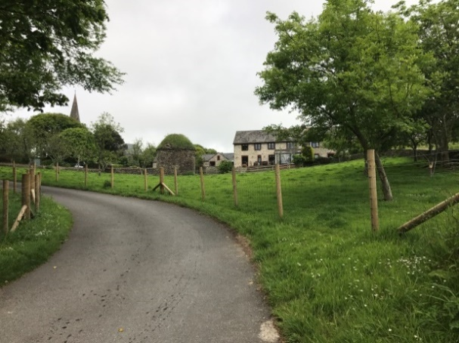 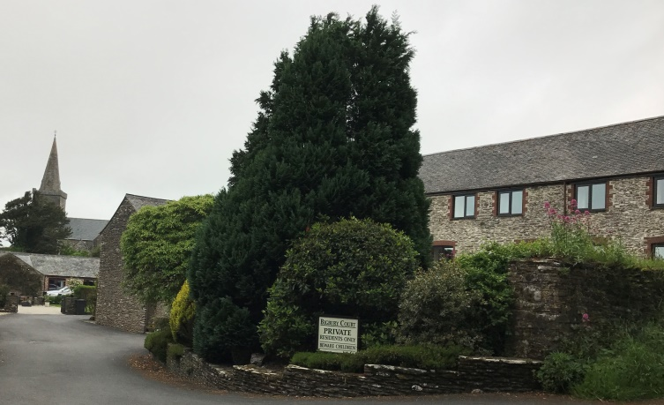

The tower and spire of the Grade 11* listed St Lawrence Church, which lies to the north of Bigbury Court, can be seen from the main road but the only public access to the church is from Undertrees Lane, a single track road leading north from the B3392 junction at Pond Green just to the east of this group of buildings.

There is an attractive complex of converted barns, previously part of Bigbury Court, to the north of the open space. These properties are accessed from Undertrees Lane.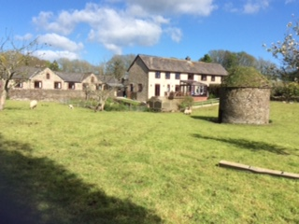

A large detached property of 1950’s build, The Old Rectory, is located to the east of the open space on the corner of the B3392 and Undertrees Lane. The house and rear garden are set at a higher level from the main road giving this property a prominent position when viewed from the south.

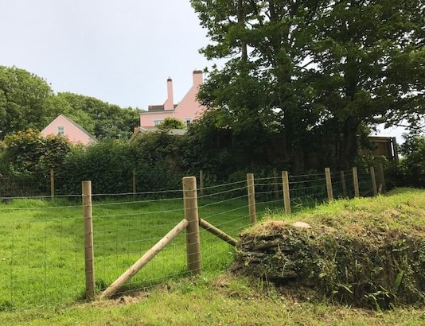 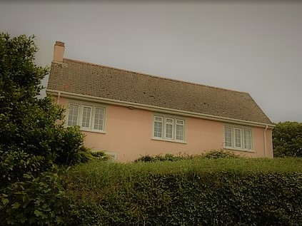

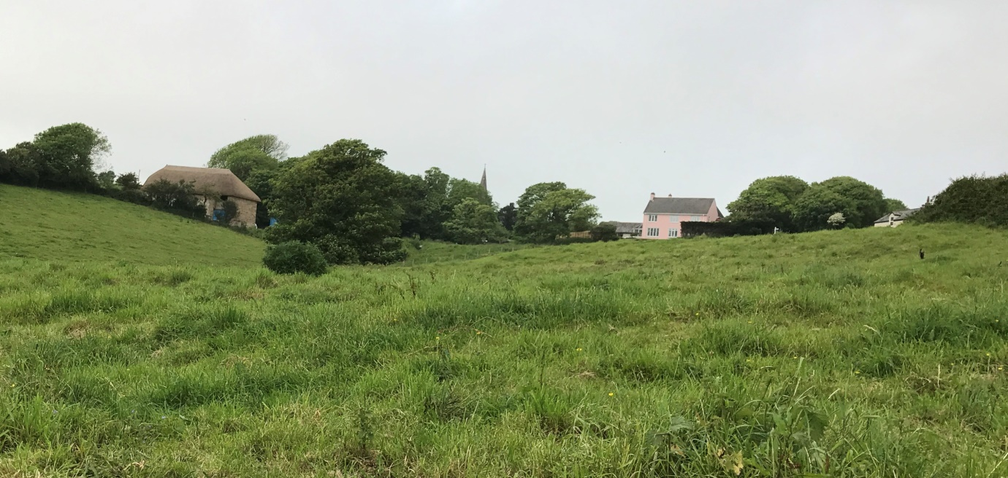

To the south of the B3392 when entering the village is Butterwell Barn, a former barn which is being converted into a dwelling. An attractive pond has been created on land to the east of the former barn as part of this residential conversion. It is understood that there was previously a village pond across the road from here. The provision of this new pond which can be viewed from the road is an interesting feature which has also attracted several wild ducks.

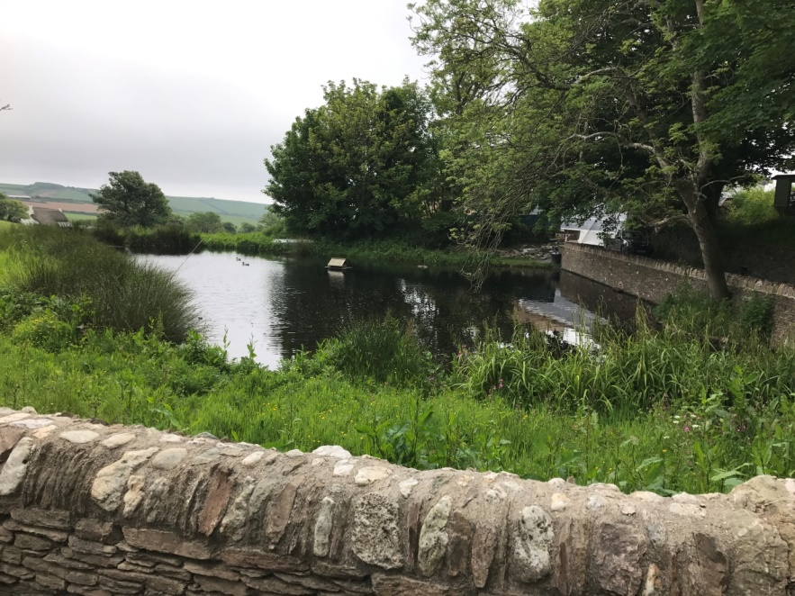

Apart from Butterwell Barn, in this northern part of the village all land to the south and west of the B3392, is in agricultural use providing spectacular open views down the valley to the sea at Challaborough Bay. There are also views across this open land to The Royal Oak public house with two storey terraced cottages on either side creating a lovely picturesque approach to this village. It is considered important that these areas of open land and important distance views across and down the valley should remain.

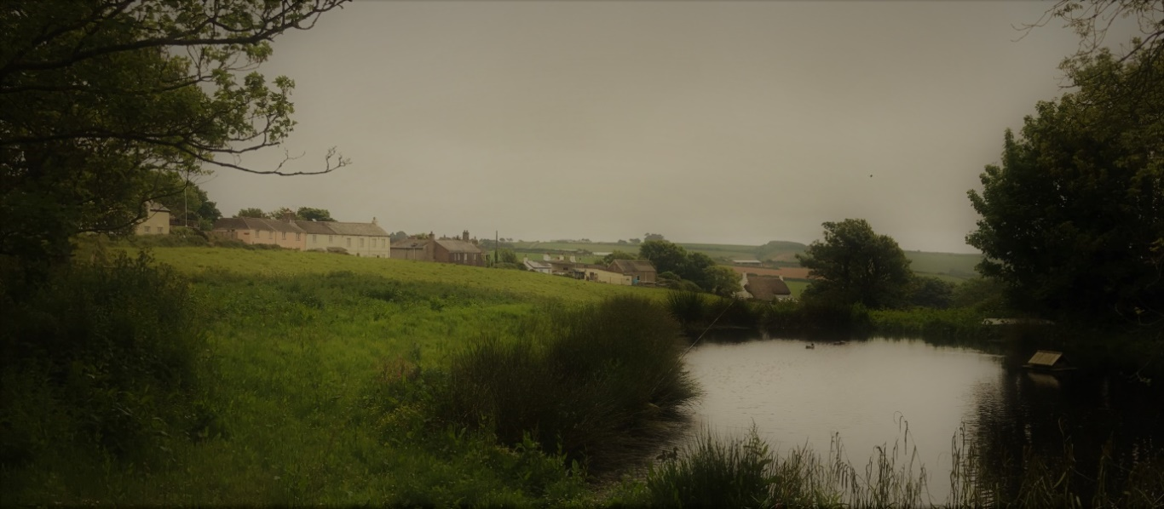

Beyond the Pond Green junction the road curves round to go south. The first building on the east side of the road is a detached one and a half storey dwelling which was formerly The Village Institute. This property was extended and converted to a house, renamed Walters End.

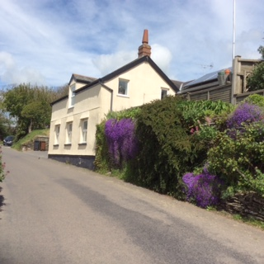

To the south of Walter’s End is a terrace of 17th century two storey terraced properties which includes The Royal Oak Public House. Two of the cottages were converted to form The Royal Oak Public House in 1850 and in the 1930’s a further cottage to the south was demolished to provide a car park. At the time of the survey the public house was closed with all windows boarded up.

Beyond this is a terrace of three cottages (originally four). The exact date of the construction of these cottages is not known but they would probably have been built in late 18th or early 19th century.

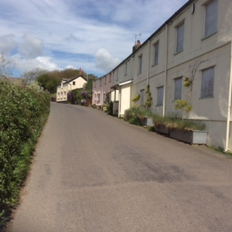

From The Royal Oak PH the view looking south down the road is terminated by the now rather poor appearance of the closed garage and petrol filling station. The appearance of this site would be improved by the removal of the redundant canopy of the former petrol filling station. However, the renovation of the former shop premises to the side of the garage to provide a beauty salon and hairdressers has greatly improved the appearance of this part of the site and provides a community facility which is well used by many of the parishioners and provides much needed employment opportunities.

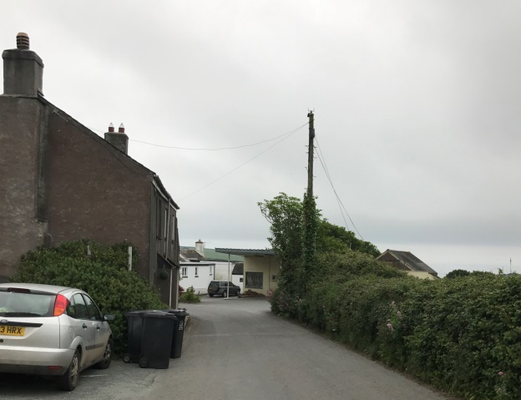 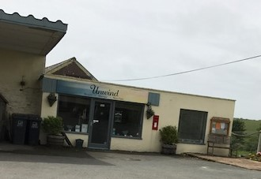

A sharp westerly bend in the road leads to the village green which is surrounded by two storey residential properties. Many of these are cottages which were built in the 17th century including Sea View Cottage on the north side, adjacent to which was the school, then a chapel and later a Penny Reading Room), On the east side are two Grade 11 listed properties, Cleave Cottage and Old Post (former shop and post office) and Bigbury Cottage (former public house) lies to the west.

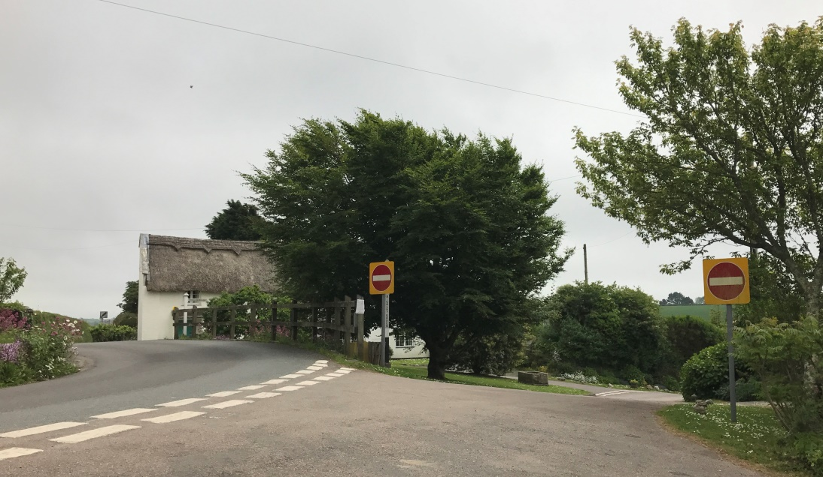

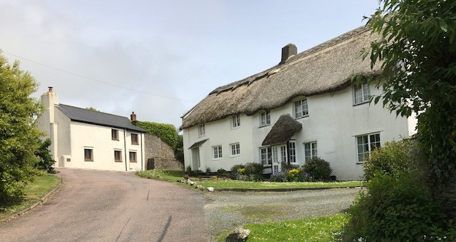

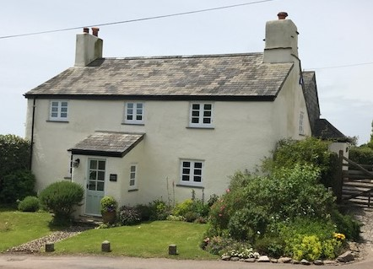

Also on the west side is a pair of semi-detached houses with Greenways, previously used as the teacher’s house, and Bay View, used as the police house. There are three terraced cottages (Mariners Cottage, Rose Cottage and Lavender Cottage) built in the 17th century and Glen Cottage (listed Grade 11 and built in the 17th century), down a short track, which becomes a footpath, leading to Ringmore and Challaborough, to the west of the green.

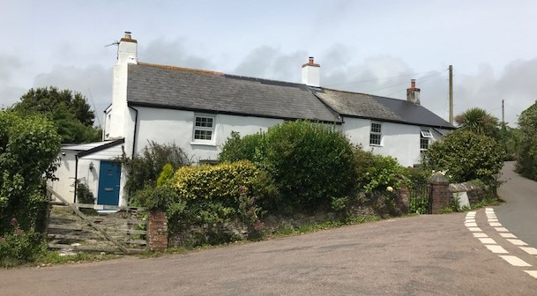 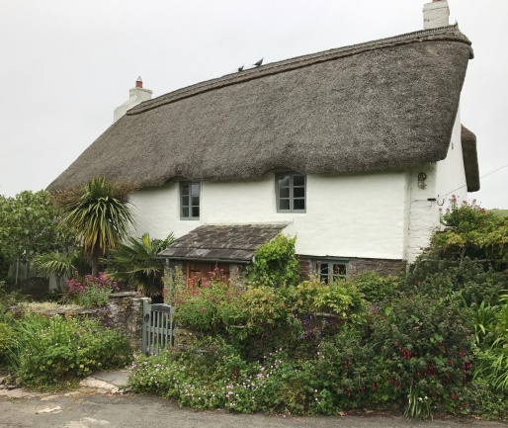

Badgers Drift, a large detached house with a prominent position on the north side of the green is the only post-war house in this group.

Beyond the village green there is one other property, Little Court which lies on the south side of the B3392. This is a post war detached property built for the local farm foreman.

The B3392 then carries on in a first south easterly and then southerly direction towards Bigbury on Sea. There is also a single track road leading south from the village green to the lower village.

Lower village

There are a two small 17th century cottages on the east side of the single track road leading down from Bigbury Village Green but the main part of the lower village, known as Lower Town or Bottom Town is located approximately 100m down this road at the junction of this road and Cot Lane. Here are a group of attractive mainly 17th cottages, three of which are Grade 11 listed, Turtlefields, The Retreat and Rose Cottage. The entrance to Lower Willings Farm is also at this junction and there are some converted barns built in the 1870s and Upper Willings Farm now used as a family dwelling house on the west side of the road.

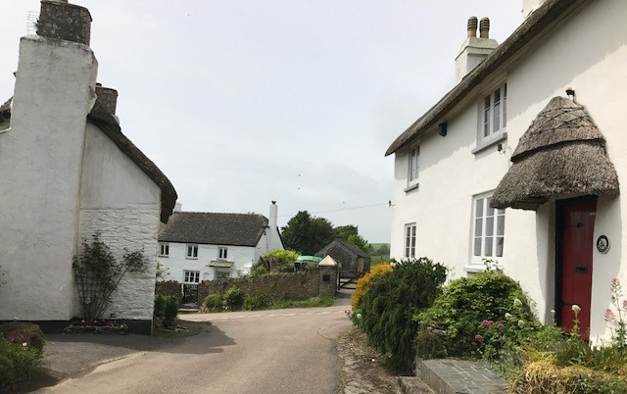

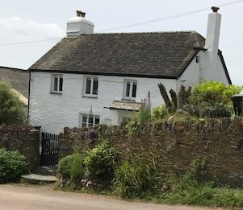 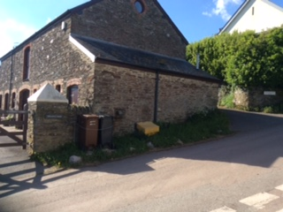

The lower part of the village was extended in the post war period with several individually designed and fairly large detached properties. These are built on the north side of the road only taking advantage of the sea views from these slightly elevated positions. The 17th century cottage, Greystones is also situated on Cot Lane.

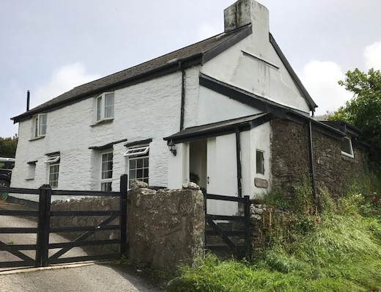

**House Types and Design**

The village of Bigbury has a very distinctive local character. Many of the properties are

small two storey terraced or detached cottages dating from the 17th or 18th centuries

although there are a few slightly larger properties built in the 20th century.

The 17th century cottages were constructed in partly stone and partly cob, now rendered.

Many of these still have thatched roofs although some have been reclad with slate. Many

also have front porches with thatched or slated roofs. The windows are primarily small six

paned timber casement windows with the first floor windows set close to the eaves.

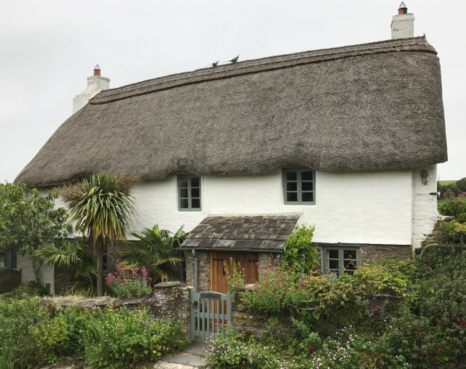 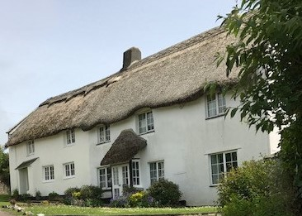

 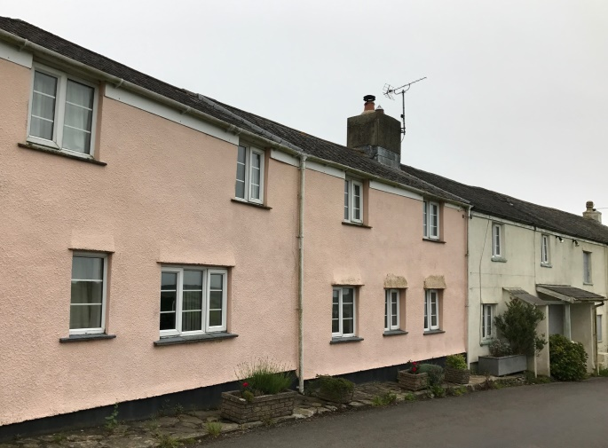

The 18th century (or early 19th century) cottages are similar in design with small usually six

paned timber paned casement windows with the first floor windows again positioned close

to the eaves. These cottages are mainly rendered or covered in pebble dash and the roofs

are clad in slate.

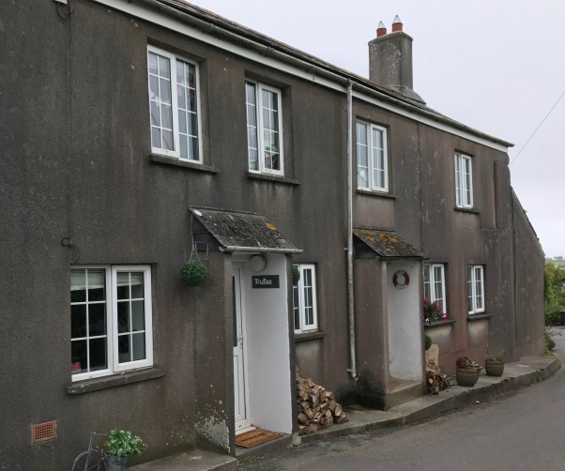 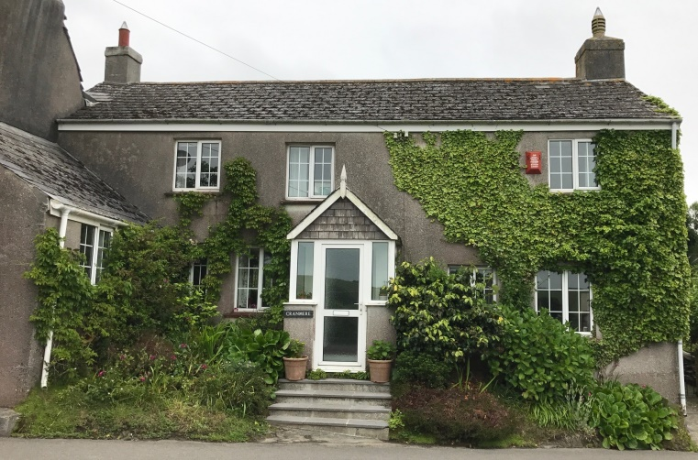

There are a few larger detached two storey houses, with those in the upper part of the village ie The Old Rectory, Badgers Drift and Little Court, commanding fairly prominent positions. These newer properties are however of fairly traditional design with windows which are not overly large in size. Materials used are also similar to those of the older buildings ie walls in painted render, timber windows and doors, walls and roofs clad in slate.

The lower part of the village is also characterised by an abundance of 17th century two storey cottages of similar design to those in the upper village. The later built properties along Cot Lane are of individual design with some displaying more contemporary features such as larger areas of glazing and balconies.

There are also a number of barn conversions within the village, notably Bigbury Court Barns, Willings Farm Barns and Butterwell Barn.

Most of the properties within the village have their own off street car parking space and most have fairly generous rear or side garden areas. Many of the older properties also retain their original pig stys.

**Historic Context**

Bigbury Conservation Area

Most of the village is within a conservation area. This extends from St Lawrence Church and Bigbury Court in the north to the junction with Cot lane within the lower part of the village to the south. The conservation area includes Butterwell Barn and the fields to the east and south of this property and the fields to the south of Glen Cottage and Bigbury Cottage.

The conservation area excludes one property, Little Court in the upper village, which is of later build, and the newer properties along Cot Lane in the lower village.

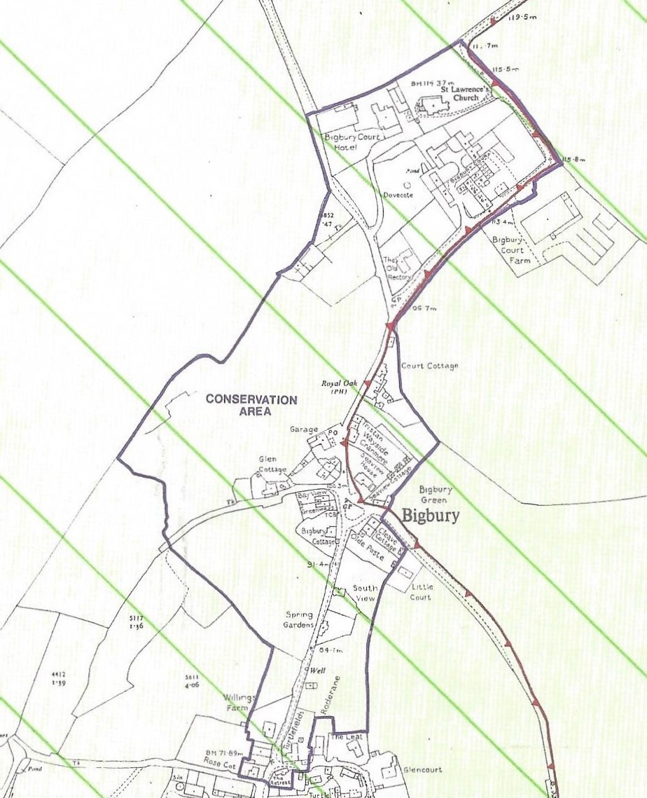

Listed buildings

There are several listed buildings in the village. These include:

St Lawrence Church including gates, piers and walls,

Bigbury Court and Dovecote to the south east,

Barn and Malthouse to the north east of Bigbury Court,

Glen Cottage,

Bigbury Cottage,

Cleave Cottage,

Old Post,

Turtlefields,

The Retreat, and

Rose Cottage.

Buildings and features of local heritage importance

Buildings and structures in the village which are not listed but are considered to be of local architectural importance are as follows:

Bigbury Court Barns,

Butterwell Barn,

The Old Rectory,

Walters End,

1 & 2 Court Cottages,

The Royal Oak and the Horse Mount,

Tristan, Wayside and Cranmere,

Lavender Cottage, Rose Cottage and Mariners Cottage,

Bay View and Greenways,

Sea View Cottage,

South View,

Spring Gardens Cottage,

Willings Barn,

Turtle Farm, Cot Lane,

Greystones,

Well in field to north of Bigbury Court,

Well on road leading to the lower part of the village,

Pump on Cot Lane, and

Milk churn stand on road in front of Bigbury Court Farm.

**Landscape and Visual Amenity**

The main road to Bigbury Village from the north, B3392, is fairly narrow with high Devon banks on either side. On entering the village from the main road the views of the village suddenly open up when reaching the first properties with Bigbury Court on the left and Butterwell Barn on the right. There is a wonderful view across open fields to the low rise cottages and The Royal Oak and a spectacular view down the valley to the sea at Challaborough Bay. The high Devon banks, stone walls and views down the valley and across beautiful open countryside are important to the village and should remain.

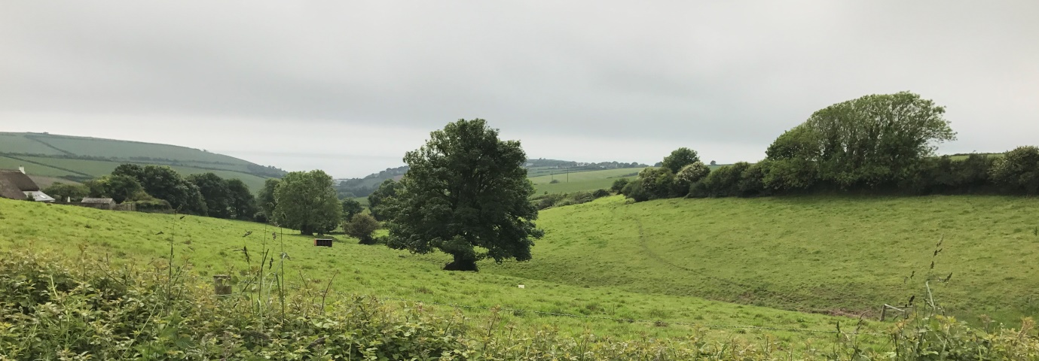

The single track road from the Pond Green junction, Undertrees Lane, also includes high stone walls, Devon banks and is lined with tall trees on either side of the road. This road leads to the Bigbury Court Barns complex, with views of the tower and steeple of St Lawrence Church.

The setting of the historic church with its lovely tower and spire, stone piers and gates at the entrance and the graveyard surrounding the church, also provides an important visual amenity which needs to be protected. The stone balls on the top of the piers were originally on the stone piers which formed the main entrance to the manor house at Bowls Green. The manor house when originally built faced north rather than south.

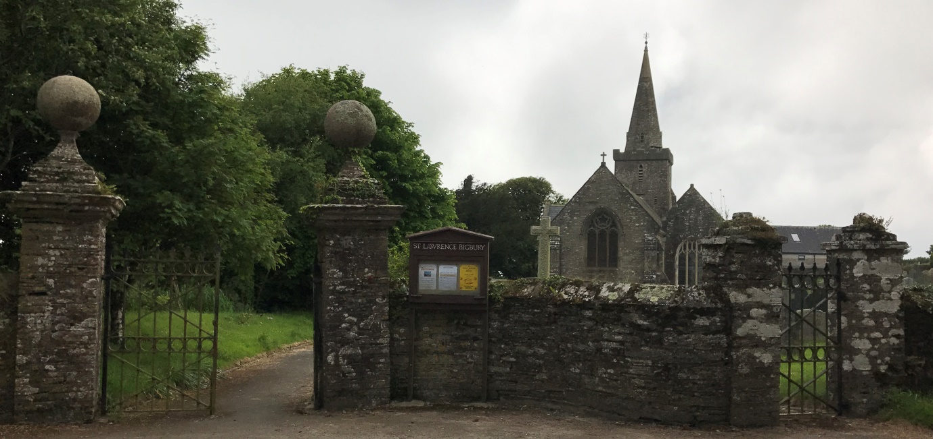

The single track lane leading down to the lower part of the village is also an attractive route which is enhanced by high Devon banks on both sides. Views of the lower part of the village open up at the junction of this road and Cot Lane forming the centre of this part of the village with historic dwellings on all sides.

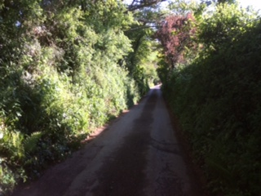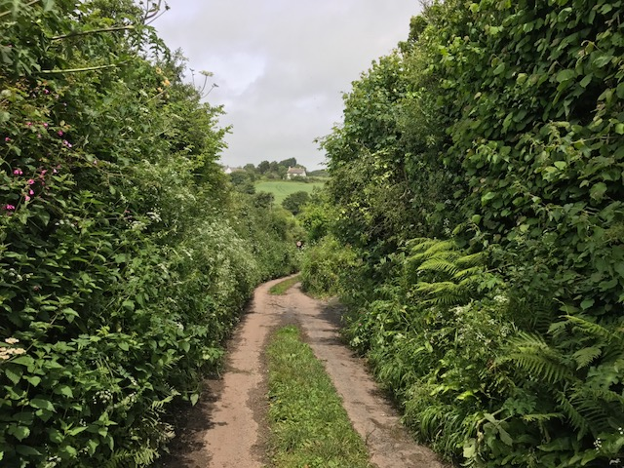

There are several areas of private and public open space which are important to the village and need to be protected.

Of particular importance is the area of private open space in front of Bigbury Court, which includes a listed Dovecote and provides a wonderful setting for the historic properties which surround this space as well as an attractive setting for St Lawrence Church to the rear.

The village green which forms the heart of the village is also important to the character and appearance of the village and provides an important meeting place for the local community, particularly on Christmas Eve when the community traditionally gather for ‘Carols on the Green’.

**Trees**

All of the trees in the conservation area, apart from fruit trees are protected. A large number of the trees are Sycamores but there are a variety of trees, some being of particular importance including those on the village green (Oak, Beech, Mountain Ash and Holm Oak), some large and very old Oak trees in the open fields on the western side of the village, and the row of Ash trees in the rear garden of the Royal Oak Public House. A young Oak tree was also planted in the rear garden of the Royal Oak Public House in the early 1980s. This is in good condition and should be retained if possible as part of any new development.

Trees, hedgerows and Devon banks are important to the appearance and character of the village and provide an important habitat for wild flowers, birds and all types of wildlife and should be retained wherever possible.

**Sites for potential development**

Bigbury Village is not suitable for any major development. It does not meet the criteria of a sustainable village and most of the village is within a conservation area.

There are however three potential sites for development.

The first site is the site to the rear of The Royal Oak for which permission has already been granted for four dwellings.

The second site is a small unused field to the north of The Old Rectory where a development of one or two houses might be acceptable subject to not causing harm to the outlook and views from properties in Bigbury Court Barns.

The third site which would appear to be suitable for development is the site of the former garage and petrol filling station. It is however considered that provision should be made for the retention of some employment uses on this site, including the beauticians and hairdressers, or other type of local community facility.